**Software Requirements Specification**

**For**

**DMS-CR Project**



**Prepared By**



13, Kazi Nazrul Islam Avenue, TK Bhaban (Level 7),

Dhaka 1215, Bangladesh

Web: www.primetechbd.com

Email: info@primetechbd.com

Contents

1. FR 1- Cluster Market Concept 3

2. FR 2- Automated triggers In Notification section (if required Notification section revamp) 8

3. FR 3- Bulk upload process of retailer NID 16

4. FR 4- Multiple device logins vetted by ZBM role and visibility on multiple devices of retailers, retailer app Integration (INT). 19

5. FR 5-Report data from retailer app / DWH: (int + ext.) 22

6. FR 6- The issued device should be migrated to a new DD when retailer migration to another like SIM/SC migration. 23

7. FR 7- Smart Search 24

8. FR 8- In Add/Edit Retailer Type. 29

9. FR 9- POSM Product 33

10. FR 10- Change in ISSUE TO RETAILER, RECEIVE DEVICE FROM RETAILER: include Retailer search. 38

11. FR 11- Mark retailer’s device as faulty/damaged (Same Process of marking sim as faulty.) 39

12. FR 12- User Response and Feedback capturing. 42

13. FR 13- Site-wise KPI report in DMS (l KPI by admin user). 43

14. FR 14- Deno Checking daily User count (9133). 45

15. FR 15- Site wise report revamp (both mail communication and DMS new report FR#13) 47

16. FR 16- SRAN Site Tagging option in BTS site list of DMS 48

17. FR 17- Retailer Database (Internal, External, and Dump) revamp. 50

18. FR 18- TMO option eliminate and redesign Merchandiser structure. 51

19. FR 19- DMS Dashboard Revamp 52

20. FR 20- In BTS Information, the inclusion of Bangla Fields. 53

21. FR 21- Weekly Update (Generate Report). 54

22. FR 22- On the Merchandiser, the New/Edit page includes the Designation column. 55

23. FR 23- EV balance return option in DMS. 58

24. FR 24- Distributor Stock Floor Report (SC). 61

**Technical Requirements/****Interfaces**

# FR 1- Cluster Market Concept

**Reference:** FR 1 (DMS) (Business Recruitments Document)

**Functionalities:**

1. Featureto create and EDIT cluster names; ID, CM Name, Description, Market value range (business value in money from amount-to-amount range), remarks; Current CM list generates.
2. Feature to download format and upload distributors vs CM name (Distributor Code, CM Name).
3. Feature to Include CM in reports (RDB, Itop-up (lifting, balance, sale), SIM lifting, SIM Issue, SIM channel fill, SC Channel fill reports.).
4. Current CM – Distributor tagging generate (CM, Distributor code, Name, Region, Cluster region, territory code, Master SIM).
5. Current CM – In edit list excel export of the whole CM.
6. Report -- generate report Distributor tagged with CM.

Interfaces:

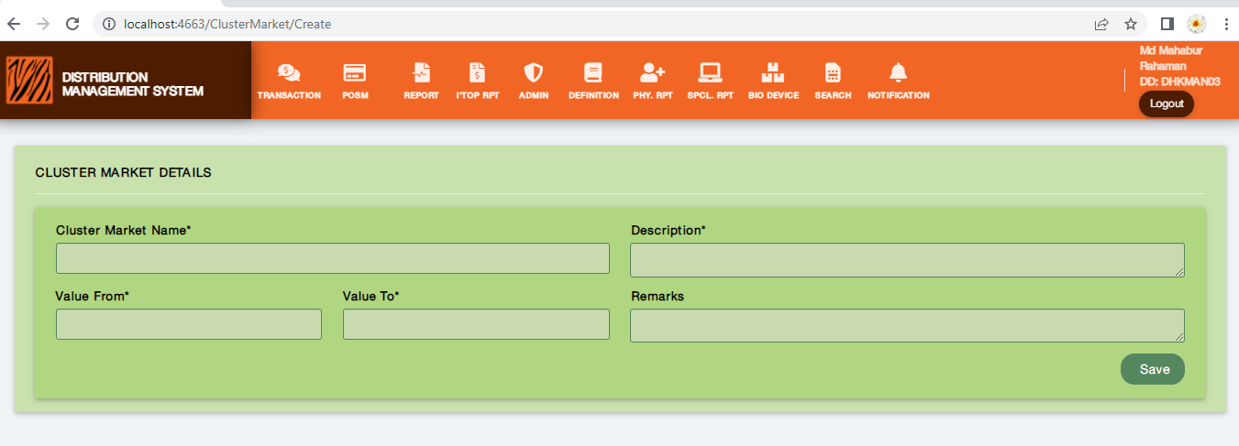 Figure: 1.1 Cluster Market Add

Cluster Creation Process:

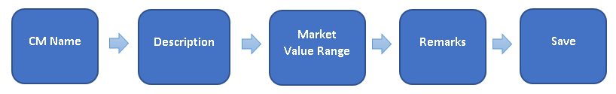

Description: The Above process demonstrates how a user will add Cluster Market.

* CM Name: CM Name field is to input Cluster Market Name. It is a mandatory field.
* Description: It is a field for detailed information for the Cluster market. It is a mandatory field.
* Market Value Range: It is input fields of only integer numbers in the “From” and “To” fields. These are also mandatory fields.
* Remarks: It is a field where the user can input any remarks if he/she wants to. It is not a mandatory field.

**Rules/Validation:**

1. CM Name: It is a text field. It is a mandatory field.
2. Description:It is a text field. It is a mandatory field.
3. Market Value Range:These must be integer numbers. These must be positive values and can’t be negative values. From value is always lesser than To value. From value and To value can not be the same.
4. Remarks:It is a text field. It is a non-mandatory field.

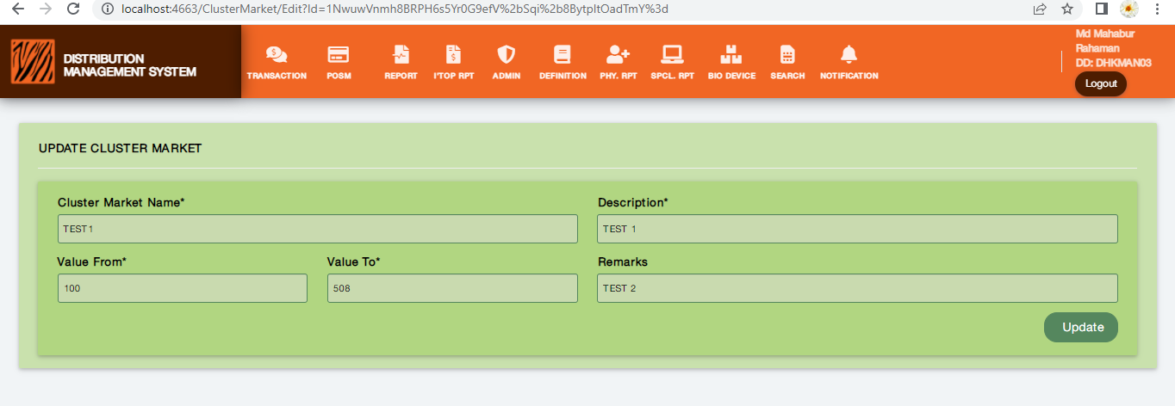 Figure: 1.2 Cluster Market Edit

Cluster Edit Process:

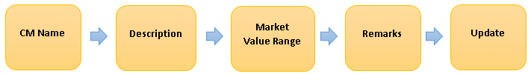

Description: The Above process demonstrates how a user will edit Cluster Market.

* Edit: The user can see the edit button and after clicking it user can edit the previously saved information.
* Update: After finishing the editing user can save the information by clicking the Update button.

**Rules/Validation:**

1. CM Name: It is a text field. It is a mandatory field.
2. Description: It is a text field. It is a mandatory field.
3. Market Value Range: These must be integer numbers. These must be positive values and can’t be negative values. From value is always lesser than To value. From value and To value can not be the same.
4. Remarks: It is a text field. It is a non-mandatory field.
5. Cancel: There must be a cancel button or feature to cancel the operation while updating if users want to cancel.

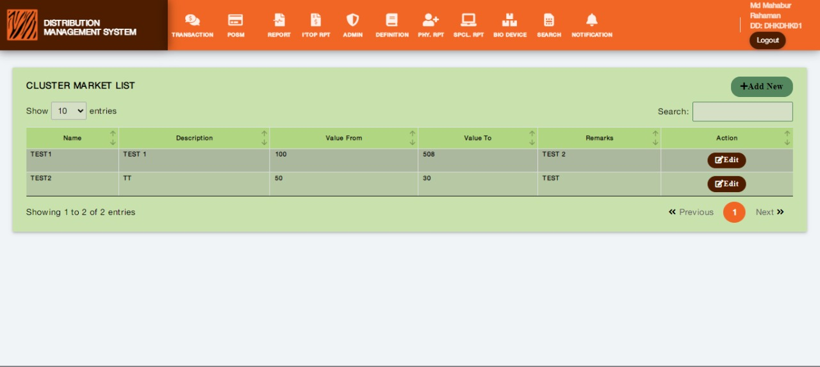Figure: 1.3 Cluster Market List

Description

* Cluster Market List: The user interface where users can see the saved information from CLUSTER MARKET ADD in lists.
* Edit: Users can see the lists and will get an edit option for each saved data. Users can edit by clicking edit then save the data by clicking the update button. Users also can cancel the edit by clicking X.
* Delete: Users can see the delete button for each row of data and can delete the data by clicking and confirming the delete operation.
* Export Excel: Users can export, download the CM List through the EXPORT EXCEL button.

**Rules/Validation:**

1. The list’s headers must be visible clearly.
2. Cluster Name Unique/duplicate check required. Relation of Cluster Market to Distributor is One to Many relations.

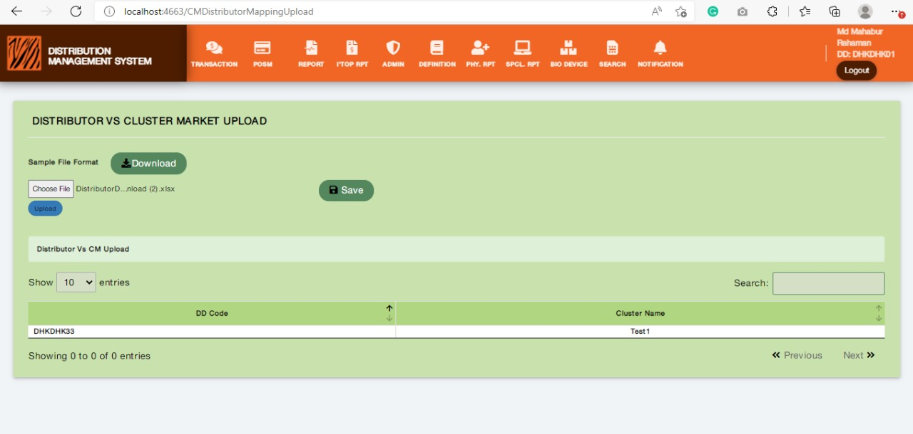Figure: 1.4 Upload Distributor VS CM Name

Process:

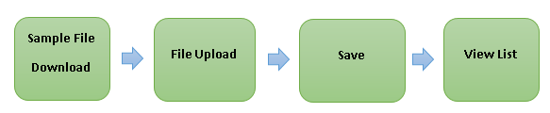

Description: The Above process demonstrates how a user will upload distributor vs CM Name.

* UPLOAD DISTRIBUTOR VS CM NAME: A user interface where users can see the Sample Format Download button, File Upload system, and can see the lists of Validation, Distributor Code, and CM Name.
* Sample Format Download: Users can download a sample format of an excel file about how he/she should maintain the uploading file.
* File Upload and Save: Users can choose the uploading data file from the computer and save it with the save button after uploading.
* DISTRIBUTOR VS CM NAME List: Users can see the uploaded file as a list of Validation, Distributor Code, and CM Name.

**Rules/Validation:**

1. Users must get the appropriate format when downloading by clicking the Sample download Format button.
2. The download file must be in excel format.
3. The list must be visible with the headers.

# FR 2- Automated triggers In Notification section (if required Notification section revamp)

**Reference:** FR 2 (RSO, DMS) (Business Recruitments Document)

**Functionalities:**

1. **Morning (Opening) Table view**
2. Zero Stock retailer count (count, pressing on count will generate details (Retailer code, itopup number, rso code, product code, stock count) in excel) (as per DMS/MDMS existing logic)
3. Low balance retailer count (count, pressing on count will generate details in excel (Retailer code, itopup number, rso code, product code, stock count) (as per DMS/MDMS existing logic)
4. MTD Target Achievement with the required rate (count, pressing on count will generate details in excel (KPI Target, KPI Achievement, KPI run rate, KPI required rate)) (as per MDMS)
5. SAF rejection count (count, pressing on count will generate details in excel): (Retailer code, MSISDN, rejected reason, activation date)
6. **System updates from D-1 data**
7. Retailer with No route count (count, pressing on count will generate details in excel) (Retailer code, itopup number)
8. Retailer with no RSO (count, pressing on count will generate details in excel) (RSO Code, SR Number)
9. Retailer with no BTS (count, pressing on count will generate details in excel) Retailer Code, Thana
10. The device with no retailer (count, pressing on count will generate details in excel) SL/IMEI, Product Name
11. Retailer verification pending (count, pressing on count will generate details in excel) (Retailer code, itopup number, change date, changed by)
12. RSO Verification pending (count, pressing on count will generate details in excel) (RSO code, SR itopup number, change date, changed by)

**Interfaces:**

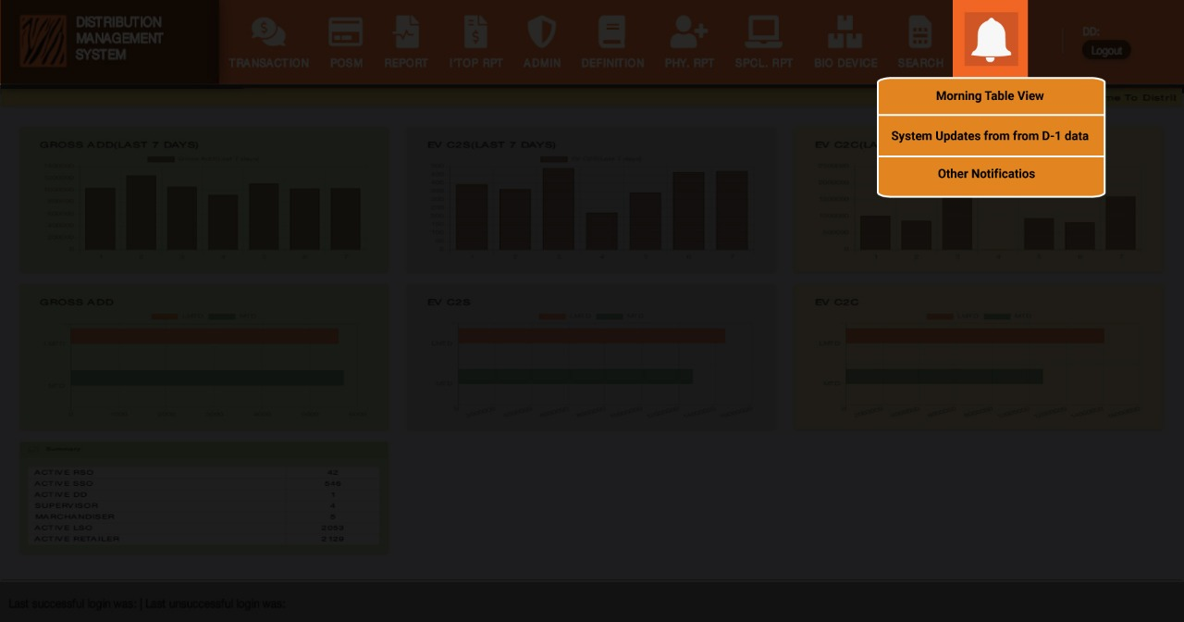**Figure: 2.1**

**Process:**



**Description: The Above process demonstrates how a user will view different types of notifications.**

**Figure: 2.1 Description**

* **Notification Icon:** Users can view all types of notifications by clicking Notification Icon.
* **Morning Table View:** Users can see morning table view notifications by this feature.
* **Systems Update from D-1 data:** Users can view systems update from D-1 data by using this feature.
* **Other Notification:** All other types of notification will be available in the Other Notification option except Morning Table View and Systems Update from D-1 data type notification.

**Rules/Validation:**

1. Users must see the dropdown menu by putting the mouse pointer on the notification icon or clicking on it.
2. After clicking the Notification Icon, the dropdown must view correctly and properly.

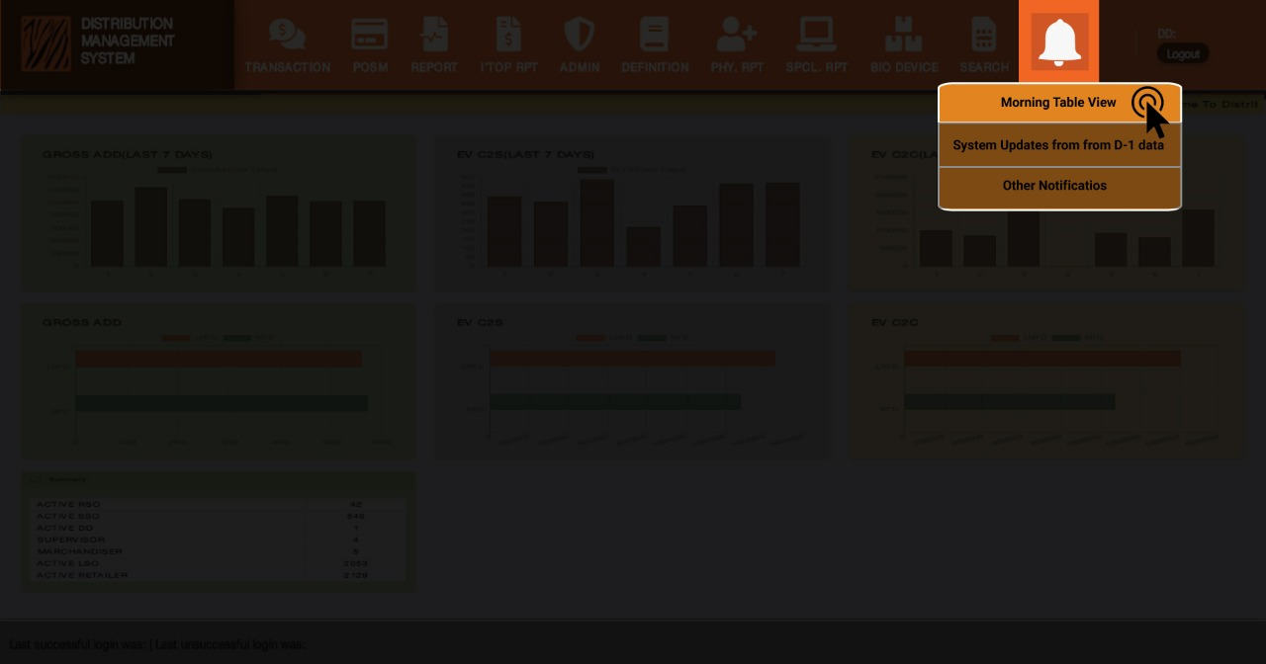**Figure: 2.2 Morning Table View**

**Description:** The Above process demonstrates how a user will Morning Table View notification.

**Figure: 2.2**

* **Morning Table View:** It is a dropdown menu feature. Users can view Morning Table View notifications specifically by clicking this feature.

**Rules/Validation:**

1. Check if the process works as description.

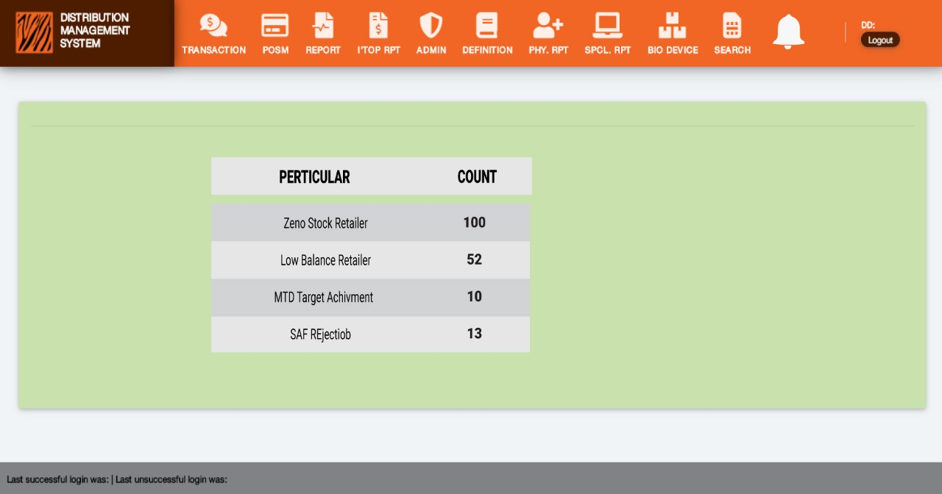**Figure: 2.3 Morning Table view List**

**Process:**



**Description:** The Above process demonstrates how a user will view the Morning Table View notification.

**Figure: 2.3**

* **Morning Table View:** It is a dropdown menu feature. Users can view Morning Table View notifications specifically by clicking this feature.
* **Particular:** It is a column field to view specific names of the notifications.
* **Count:**
* **Export Excel:** It is a feature of downloading details in an excel file by clicking on each notification name.

**Rules/Validation:**

* The list must view appropriately and clearly.
* No button or Fields must overlap or break.
* Export Excel download feature must work properly and the file must be visible in the browser’s download section.

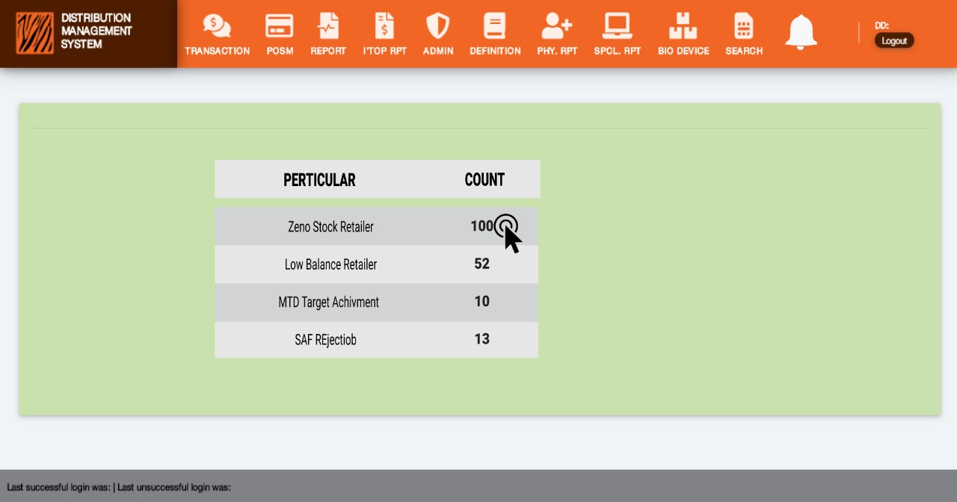**Figure: 2.4 Morning Table View (Clicking on Count)**

**Description:** The Above process demonstrates how a user will download details in an Excel file by clicking on the notification name.

**Figure: 2.4**

* **Zero Stock Retailer:** it is a notification name. Users can download a details file by clicking on it.

**Rules/Validation:**

1. Export Excel download feature must work properly and the file must be visible in the browser’s download section.
2. Download file format must be in predefined file format.

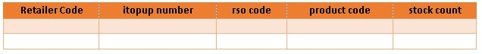**Figure: 2.5**

**Description:** The Above process demonstrates the Excel Format, column name, and fields.

**Rules/Validation:**

1. File must be downloaded as same as the above picture.

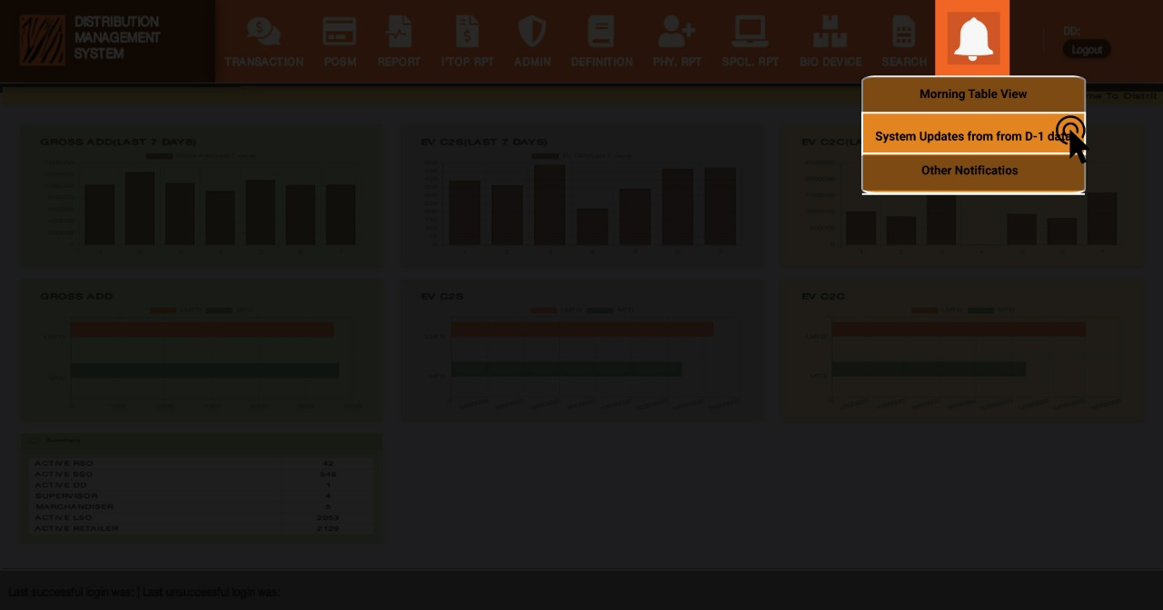**Figure 2.6 Systems Updates From D-1 Data**

**Process:**



**Description:** The Above process demonstrates how a user will view System Updates from D-1 data notification.

**Figure: 2.6**

* **Systems Updates From D-1 Data:** It is a feature to view System Updates from D-1 data notifications specifically.

**Rules/Validation:**

1. Check if the process works as description.

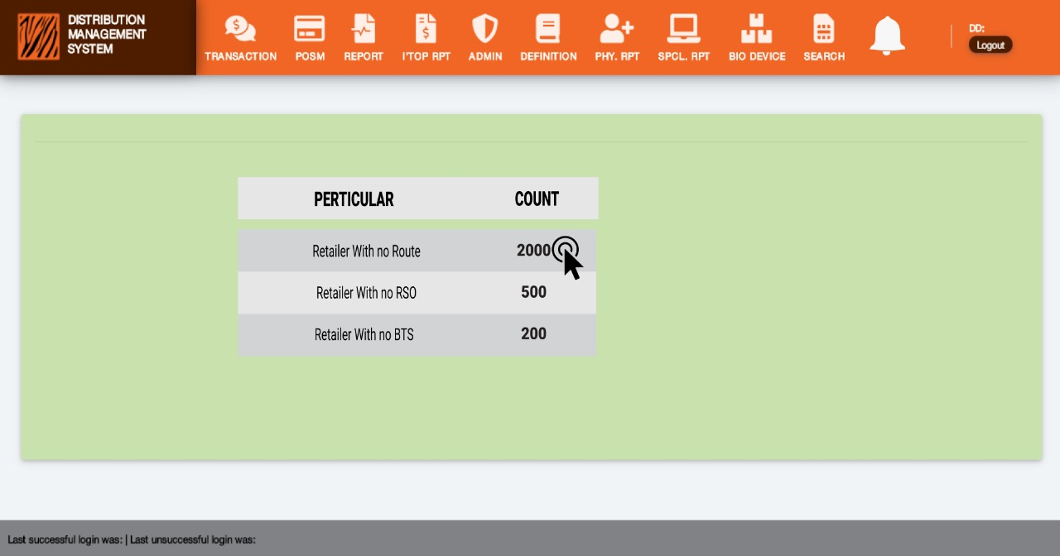**Figure: 2.7 Systems Updates From D-1 Data (Clicking on Count)**

**Process:**



**Description:** The Above process demonstrates how a user can view system update notification details.

**Figure: 2.7**

1. **Systems Updates From D-1 Data:** It is a feature to view System Updates from D-1 data notifications specifically.
2. **Particular:** It is a column field to view specific names of the notifications.
3. **Count:**
4. **Export Excel:** It is a feature of downloading details in an excel file by clicking on each notification name.

**Rules/Validation:**

1. Check if the process works as described.

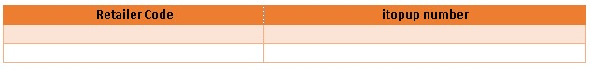**Figure: 2.8 Retailer with no Route**

**Figure 2.8:** The above picture shows the Retailer list with no Route information.

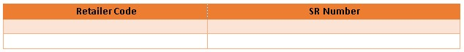**Figure: 2.9 Retailer with no RSO**

**Figure 2.9:** The above picture shows the Retailer list with no RSO information.

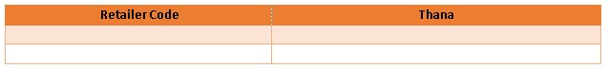**Figure: 2.10 Retailer with no BTS**

**Figure 2.10:** The above picture shows the Retailer list with no BTS information.

# FR 3- Bulk upload process of retailer NID

Reference: FR 3 (DMS) (Business Recruitments Document)

**Functionalities:**

Addition of features

1. A new upload module, Maximum upload Limit 50 Retailer one time.
2. Retailer code, NID fields will be uploaded
3. Validation Retailer code exists in DMS, NID (10/13/17 digits and number only)
4. On the verification page, retailer code, old NID, New NID will appear, ZM will review and verify at one go.
5. conditions need to check for NID upload:

* NID length must be within (10,13,17).
* Alphanumeric not allowed, only numbers are valid for input.

**Excel report export of verification pending**.

1. Pending receiving SIM from retailers
2. Pending retailer verifications
3. Pending RSO verifications
4. Pending Supervisor changes
5. Pending Merchandiser Changes

Condition: The migrated retailer has Old DD RSO codes in the retailer list and should be removed while transferring from old to new DD

Interfaces:

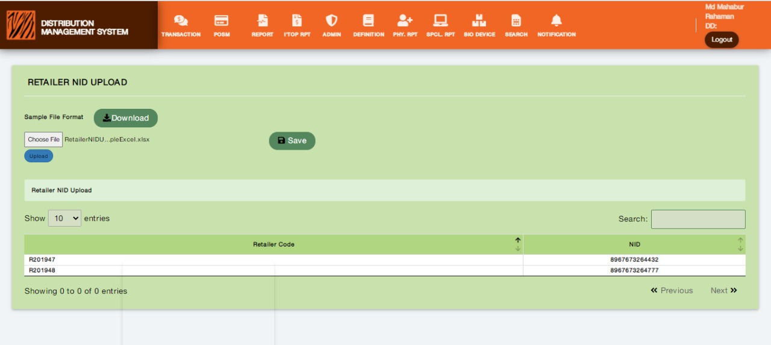Figure: 3.1 Bulk Upload of Retailer NID

|  |  |
| --- | --- |
| ReatilerCode | NID |
| R020194 | 8967575675664430 |
| R020195 | 8967673264777 |

Figure: 3.2 Sample File Format Download

Bulk Upload Process:

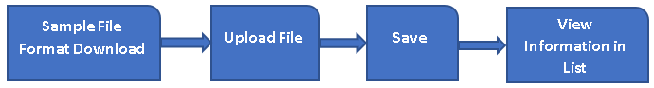

Description: The Above process demonstrates how a user will perform a Bulk upload of retailer NID.

* BULK UPLOAD PROCESS OF RETAILER NID: A user interface where users can upload the retailer nid information in bulk through an excel file.
* Bulk Upload Sample Format Download: The user can download a sample format of an excel file to get instructions about maintaining the file format as pre-defined.
* File Upload, Save: Users can choose the file from the computer then upload it or verify the file for any error, then can save it by clicking the save button. NID information will be saved in the Retailer Table. In file uploading maximum 50 retailer upload limit has been set. IF Retailer is pending or inactive, for each pending or inactive retailer messages will be shown to the user.
* List: The user can see a list of Validation, Retailer Code, and NID fields.

**Rules/Validation:**

1. Users must get the appropriate format when downloading by clicking the Sample download Format button.
2. The Upload file must be in excel format.
3. NID length (10,13,17) digits, Retailer Code must exist in DMS, Duplicate Retailer Code in Excel conditions will verify in uploading NID file.
4. NID length must be within (10,13,17) and Alphanumeric not allowed, only numbers are valid.
5. Retailer Code Must be in RDB.
6. In file uploading maximum 50 retailer upload limit has been set for each upload time. Users must check the uploading file does not have more than 50 retailer information.
7. For pending or Inactive Retailer messages must show to users.

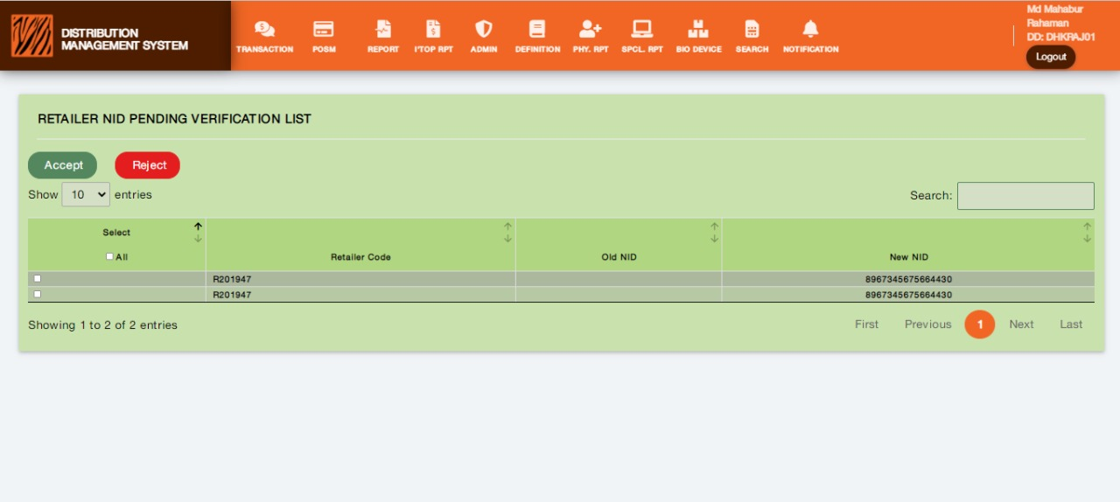 Figure:3.3 Retailer NID Verification Pending List

Process:

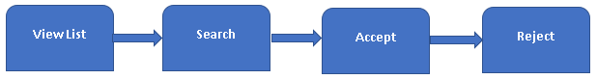

Description: The Above process demonstrates how a user will perform Retailer NID Pending verification request approval or rejection.

* Retailer NID Verification Pending List: In this interface, Users can see the requested NID verifications as pending in a list.
* Approve: Users can approve each request specifically from the list by clicking the Approve button.
* Reject: Users can reject each request specifically from the list by clicking the Reject button.
* Search: Users can search with specific information in the list like Retailer Code, NID.

**Rules/Validation:**

1. User must receive notification for search data if not found.
2. After Accepting or Reject the request should not appear in the list
3. ZM will Accept or Reject the request

# FR 4- Multiple device logins vetted by ZBM role and visibility on multiple devices of retailers, retailer app Integration (INT).

**Reference:** FR 4 (Retailer app/DWH) (Business Recruitments Document)

**Functionalities:**

1. **Multiple device login options will be approved by ZM (if more than 2/3 configurable), with multiple devices allowed count.**
2. For registration of 3rd / 4th device approval will appear in transaction > verification > Device registration approval page.
3. Retailer code, itop-up number, SR number, the device registered count, new device id, Handset model, request date; fields will appear.
4. ZM will approve or reject.
5. The request will be sent to the retailer app database, with API integration.
6. List of pending approval with the same fields can be exported in excel.
7. **On-device registration, the list will appear in report format.**

**Registered devices:** Retailer code, Device IMEI, Handset Model, Name, Unique Device ID, registration Date, modified date;

filter: snap date, retailer code, distributor code.

1. **Device wise contribution:**

Retailer code, itop-up, Distributor code, Region, Device IMEI, Handset Model, Name, Unique Device ID, date, deno amount, ev amount, IRIS amount.

Filter: date, retailer, itop-up.

(Source DWH/Retailer App).

**Condition: \*** API will be provided by the Retailer APP site.

**\*** Pending list will be exported in Excel

Interfaces:

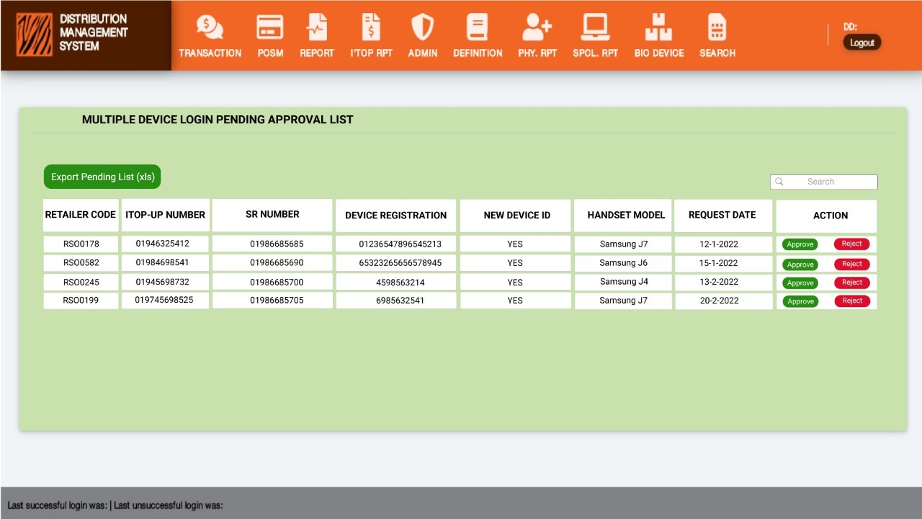Figure: 4.1 Multiple Device Pending Approval List

Device Login Pending Approval List Process:



Description: The Above process demonstrates how a user will perform approval of devices pending login info.

Figure 4.1

* Multiple Device Login Pending Approval List: Users can see the requested multiple device logins approval list here as Retailer Code, Itop-Up Numbers, SR Number, Device Registration, New Device ID, Handset Model, Request Date, and Action fields.
* Export Pending List: By clicking this button user can export, download the multiple device logins pending approval list in excel files.
* Approve: Users can approve each request specifically from the list by clicking the Approve button.
* Reject: Users can reject each request specifically from the list by clicking the Reject button.
* Search: Users can search in the list with specific information like Retailer Code, Itop-Up Numbers, SR Number, Device Registration.

**Rules/Validation:**

1. Export pending list must be downloaded in excel format.
2. User must receive notification for invalid search data.
3. After Accept or Reject the row should not be available for re-reject or re-accept.

# FR 5-Report data from retailer app / DWH: (int + ext.)

**Reference:** FR 5 (Retailer app / DWH) (Business Recruitments Document)

**Functionalities:**

**Functionalities:** Report data from retailer app/ DWH:

1. **By Date Retailer App Login**: Device IMEI, Device Model, Device Name, IS_PRIMARY, Unique Device ID, VERSION NAME, Retailer Code, itop-up number, Login Date;

Filter: Cluster, Region, Date.

**Module:** (External and Internal)

1. **itop-up Fraud Query Handling:** Retailer Code, itop-up number, Device IMEI, Handset Model, Name, Date, time, c2s amount, mode (regular / iris/ deno), customer MSISDN;

Filter: start date, end date, Region, Distributor, itopup number, customer msisdn (input) {all search fields Not mandatory}

**Module:** (Internal)

1. **Daily Retailer App Usage Report**: Region, Distributor code, itopup SR number, Retailer code, itopup number, 1st App Login date, Date, App hit count, SIM hit count, deno count, deno amount, EV count, ev amount, IRIS count, IRIS amount.

Filter: Date.

**Module:** (Internal)

1. **EV PIN Reset Summary**: Retailer Code, itop-up number, Request date-time, tempting date-time, PIN reset successful Date-time, RSO Code, SR number,

Filter retailer code, ev number, date.

**Module:** (External)

1. **EV PIN Reset Details:** Cluster, Region, Distributor, Retailer code, itopup number, SR number, rso code, Device IMEI, Device Model, Device Name, request date/time, reset by, temp PIN date-time, reset successful Date Time;

Filter date, region, retailer (input), itopup (input)

**Module:** (Internal)

**Interfaces:**

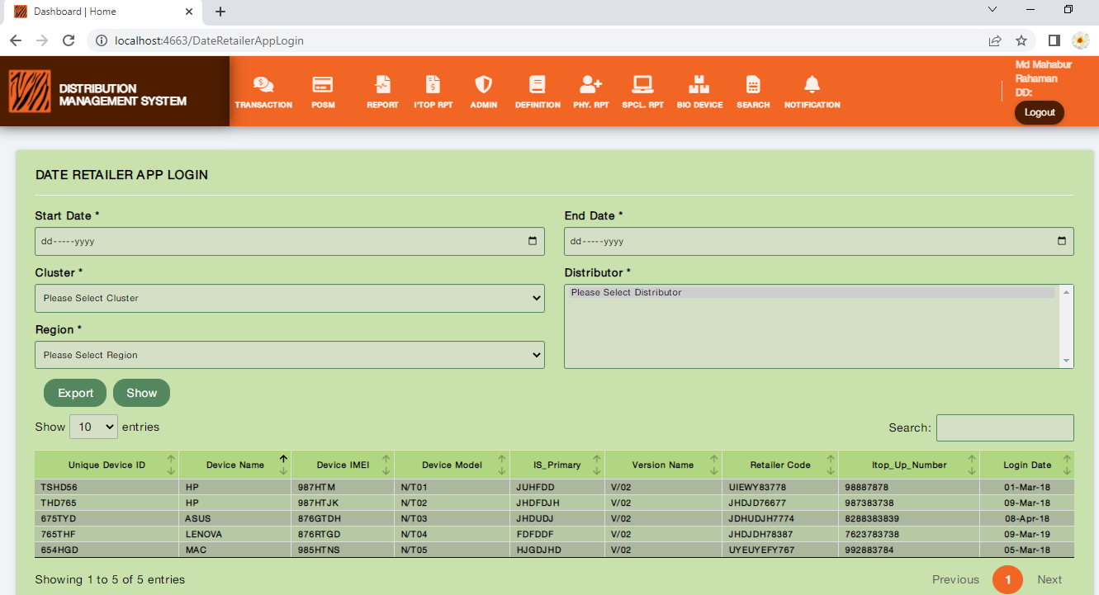**Figure: 5.1 Retailer App Login Date**

**Process:** 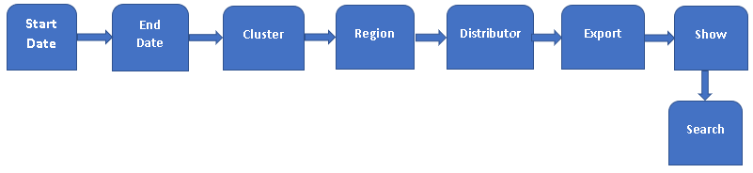

**Description:** The Above process demonstrates how a user will view Retailer App Login Information by Date.

* **Start Date:** Users can select the start date by clicking on Start Date. It is a mandatory field.
* **End Date:** Users can select the end date by clicking on End Date. It is a mandatory field.
* **Select Cluster:** Users can select cluster by clicking on Cluster. It is a mandatory field.
* **Select Region:** Users can select Region by clicking on Region. It is a mandatory field.
* **Distributor:** Users can select distributor by clicking on Distributor. It is a mandatory field.
* **Export:** Users can export the information as a report in Excel by clicking on Export.
* **Show:** After selecting all required information users can show the Retailer Login Information by date as in the List.
* **Search:** Users can search for specific information through the Search feature.

**Rules/Validation:**

1. Export button must work properly as the Excel Download of the report.
2. The Downloaded Excel file must have the fields of (Unique Device ID, Device Name, Device IMEI, Device Model, Is_Primary, Version Name, Retailer Code, Itop_up_Number, Login Date) as information.
3. Users must be able to use Filter with (Cluster, Region, Start Date, End Date).

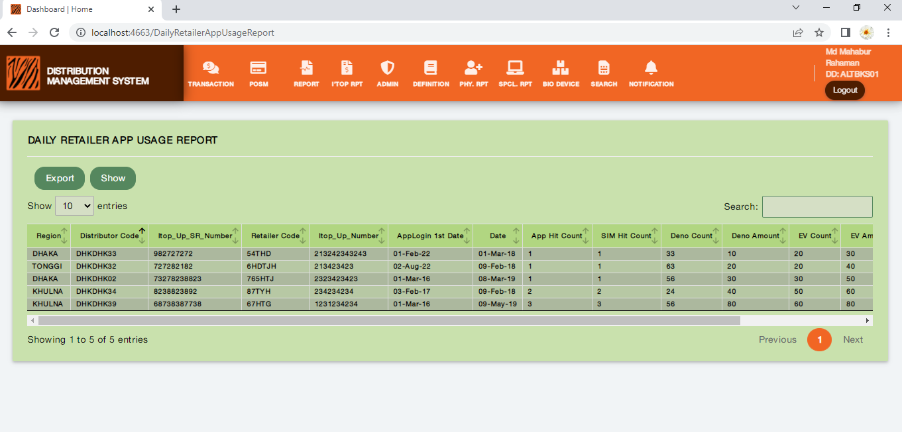**Figure: 5.2 Daily Retailer App Usage Report**

**Description:** The Above picture demonstrates how a user will view and export Daily Retailer App Usage Report.

**Rules/Validation:**

1. Export button must work properly as the Excel Download of the report.
2. The Downloaded Excel file must have the fields (Region, Distributor Code, Itop_Up_SR_Number, Retailer Code, Itop_Up_Number, App Login 1st Date, Date, App Hit Count, SIM Hit Count, Deno Count, Deno Amount, EV Count, EV Amount, IRIS count, IRIS amount) as information.
3. Users must be able to use Filter with (Start Date, End Date).

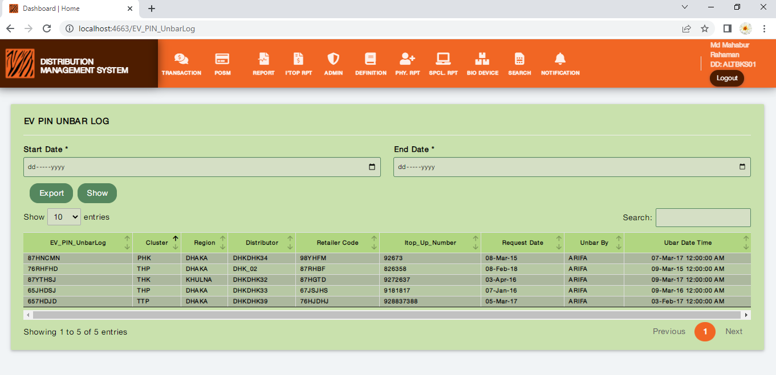**Figure: 5.3 EV PIN UNBER LOG**

**Process:** 

**Description:** The Above process demonstrates how a user will view the EV PIN Unbar Log.

* **Start Date:** Users can select the start date by clicking on Start Date. It is a mandatory field.
* **End Date:** Users can select the end date by clicking on End Date. It is a mandatory field.
* **Export:** Users can export the information as a report in Excel by clicking on Export.
* **Show:** After selecting all required information users can show the Retailer Login Information by date as in the List.
* **Search:** Users can search for specific information through the Search feature

**Rules/Validation:**

1. Export button must work properly as the Excel Download of the report.
2. The Downloaded Excel file must have the fields of (EV PIN Unbar Log, Cluster, Region, Distributor, Retailer code, Itopup Number, Request Date/Time, Unbar by, Unbar Datetime) as information.
3. Users must be able to use Filter with (Start Date, End Date, Region, Retailer (input), Itopup (input)

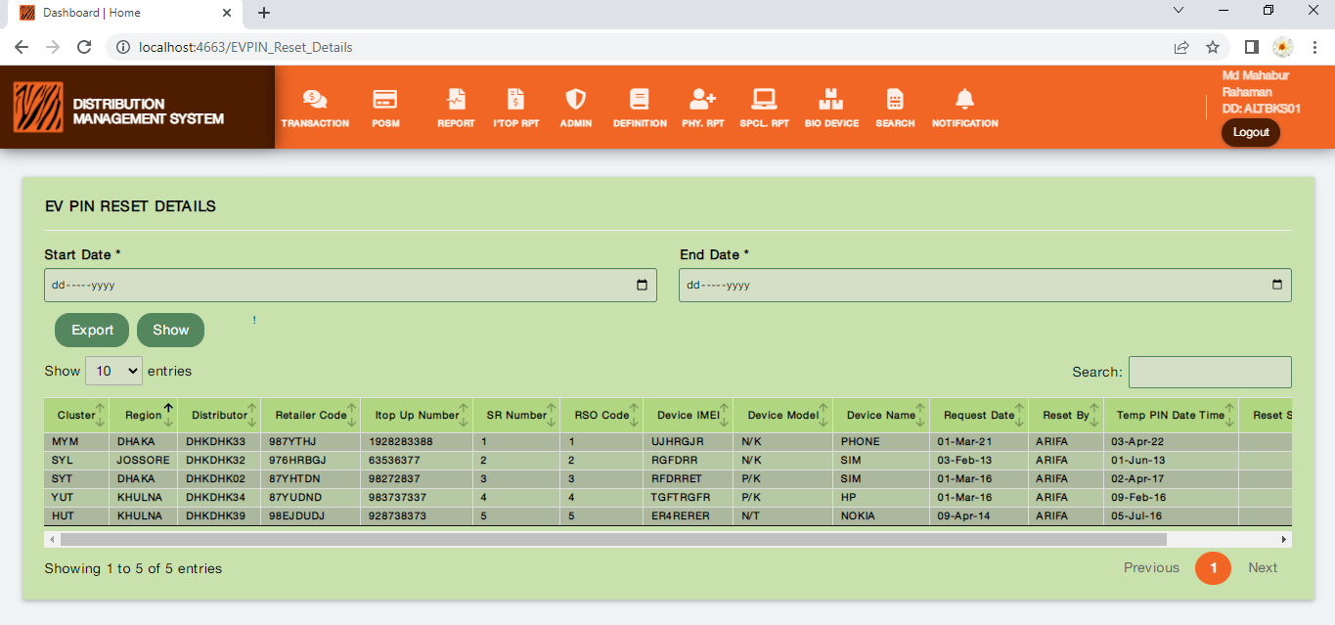**Figure: 5.4 EV PIN RESET DETAILS**

**Process:** 

**Description:** The Above process demonstrates how a user will view EV PIN Reset Details.

* **Start Date:** Users can select the start date by clicking on Start Date. It is a mandatory field.
* **End Date:** Users can select the end date by clicking on End Date. It is a mandatory field.
* **Export:** Users can export the information as a report in Excel by clicking on Export.
* **Show:** After selecting all required information users can show the Retailer Login Information by date as in the List.
* **Search:** Users can search for specific information through the Search feature

**Rules/Validation:**

1. Export button must work properly as the Excel Download of the report.
2. The Downloaded Excel file must have the fields (Cluster, Region, Distributor, Retailer Code, Itopup Number, SR number, RSO Code, Device IMEI, Device Model, Device Name, Request Date/Time, Reset By, Temp PIN Date-Time, Reset Successful Date Time) as information.
3. Users must be able to use Filter with (Start Date, End Date, Region, Retailer (input), Itopup (input)).

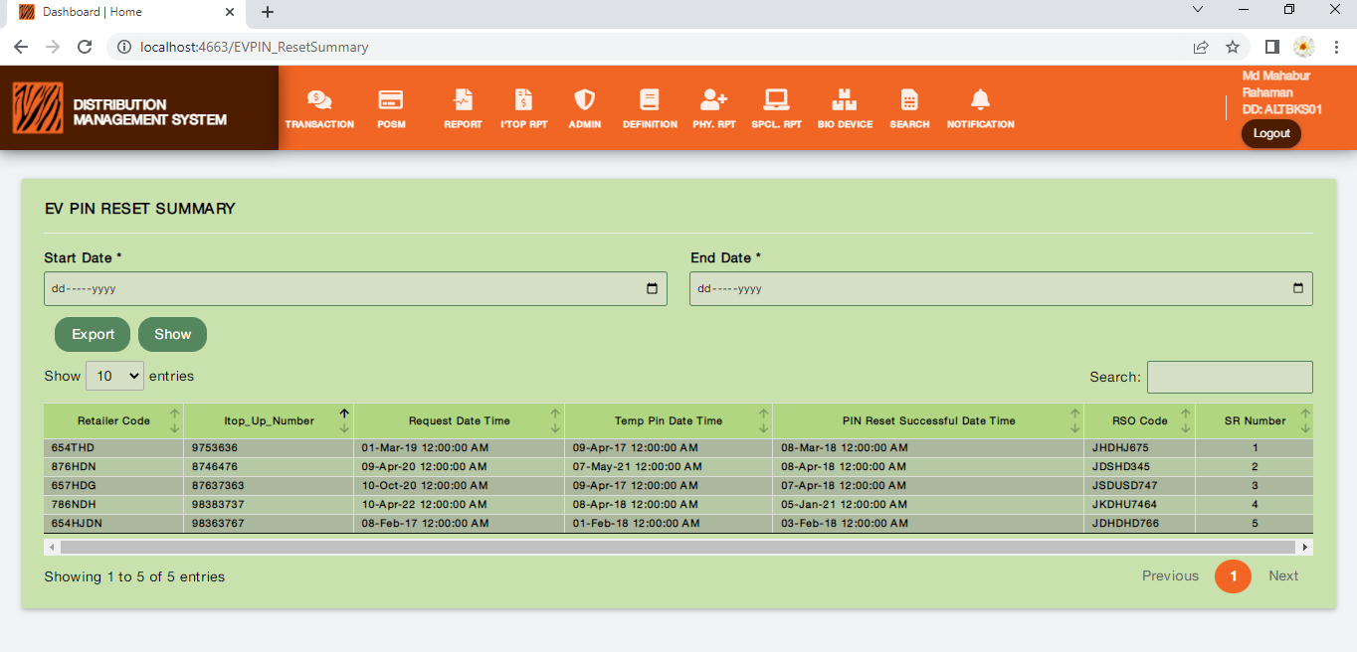**Figure: 5.5 EV PIN RESET SUMMARY**

**Process:** 

**Description:** The Above process demonstrates how a user will view the EV PIN Reset Summary.

* **Start Date:** Users can select the start date by clicking on Start Date. It is a mandatory field.
* **End Date:** Users can select the end date by clicking on End Date. It is a mandatory field.
* **Export:** Users can export the information as a report in Excel by clicking on Export.
* **Show:** After selecting all required information users can show the Retailer Login Information by date as in the List.
* **Search:** Users can search for specific information through the Search feature

**Rules/Validation:**

1. Export button must work properly as the Excel Download of the report.
2. The Downloaded Excel file must have the fields of (Retailer Code, Itop-Up Number, Request Date-Time, Tempting Date-Time, PIN Reset Successful Date-Time, RSO Code, SR Number) as information.
3. Users must be able to use Filter with (Retailer Code, EV Number, Start Date, End Date).

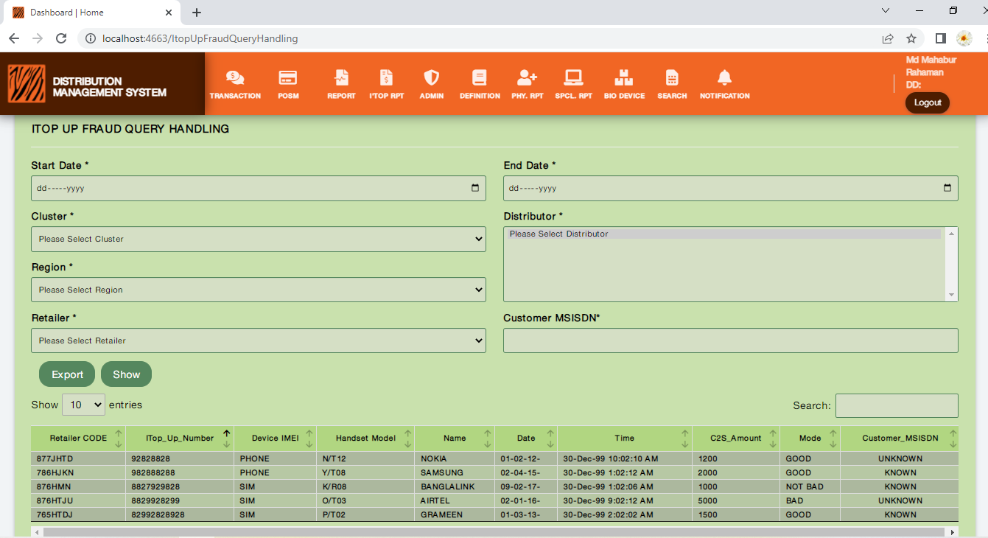**Figure: 5.6** **ITOP UP FRAUD QUERY HANDLING**

**Process:** 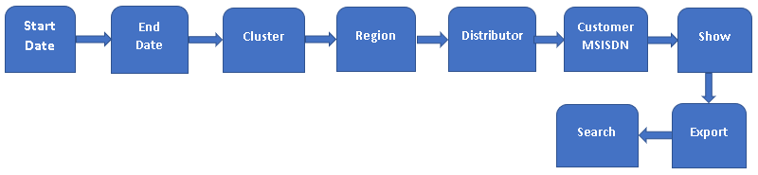

**Description:** The Above process demonstrates how a user will view ITOP UP FRAUD QUERY HANDLING.

* **Start Date:** Users can select the start date by clicking on Start Date. It is a mandatory field.
* **End Date:** Users can select the end date by clicking on End Date. It is a mandatory field.
* **Select Cluster:** Users can select cluster by clicking on Cluster. It is a mandatory field.
* **Select Region:** Users can select Region by clicking on Region. It is a mandatory field.
* **Distributor:** Users can select distributor by clicking on Distributor. It is a mandatory field.
* **Customer MSISDN:** Users can input customer MSISDN number in Customer MSISDN. It is a non-mandatory field.
* **Export:** Users can export the information as a report in Excel by clicking on Export.
* **Show:** After selecting all required information users can show the Retailer Login Information by date as in the List.
* **Search:** Users can search for specific information through the Search feature.

**Rules/Validation:**

1. Export button must work properly as the Excel Download of the report.
2. The Downloaded Excel file must have the fields of (Retailer Code, Itop-up Number, Device IMEI, Handset Model, Name, Date, Time, C2S Amount, Mode (Regular / IRIS/ Deno), Customer MSISDN) as information.
3. Users must be able to use Filter with (Start date, End date, Region, Distributor, Itopup Number, Customer MSISDN (input)).

# FR 6- The issued device should be migrated to a new DD when retailer migration to another like SIM/SC migration.

**Reference:** FR 6 (DMS) (Business Recruitments Document)

**NO User Interface Required.**

**Functionalities:**

1. Issued device should be migrated to new DD when retailer migration to another like SIM/SC migration.

**Interfaces:**

**Process:**

**Rules/Validation:**

# FR 7- Smart Search

**Reference:** FR 7 (DMS) (Business Recruitments Document)

**Functionalities:**

1. By merchandiser contact number option.
2. By TMO Contact.
3. In search result by retailer code or itopup or contact number service details like SSO, itopup, SC, type, service point required. It means adding a few more flagging in retailer search results.
4. SC range (start SC serial, end SC serial), search output same as current SC search output.

**Interfaces:**

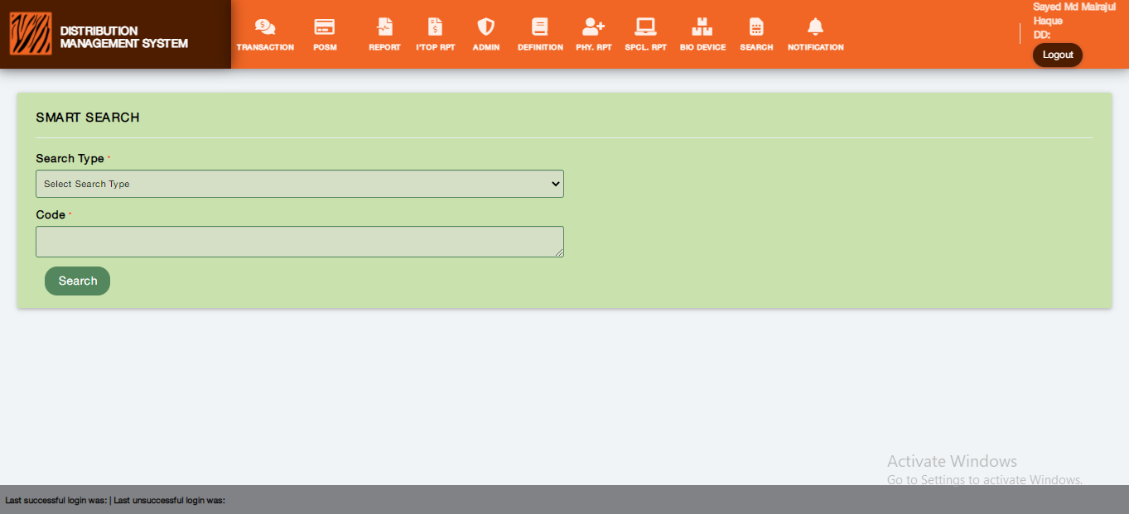**Figure: 7.1 Smart Search**

**Process:**



**Description:** The Above process demonstrates how a user will view and use the Smart Search feature.

**Figure: 7.1**

* **Search Type:** It is a dropdown menu feature to view the different search types.
* **Code:** It is a numeric field to enter a code to search specifically.
* **Search:** It is a feature to search for specific information.

**Rules/Validation:**

1. The Search Type dropdown menu options must be visible appropriately.
2. Users must be able to scroll through the menu options and able to select the required option by clicking on it.
3. If the search result is not matched or not found, Users must get a notification for that.

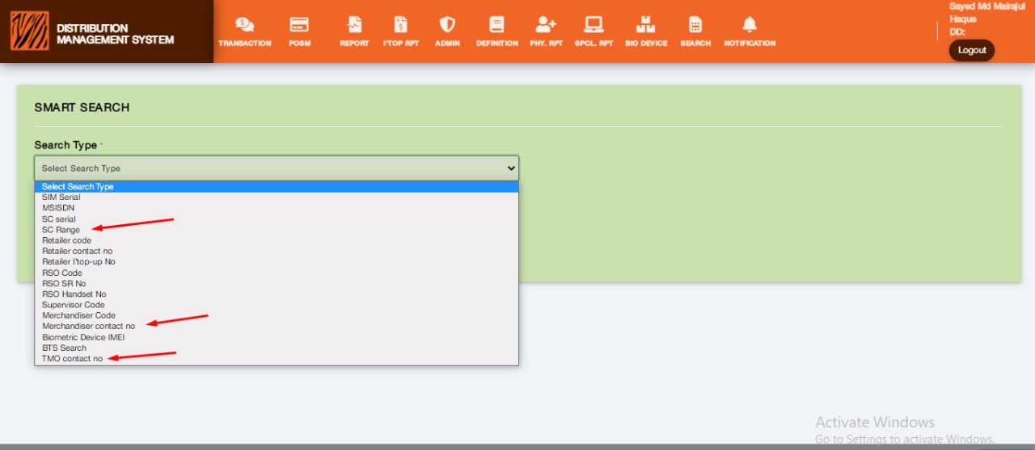**Figure: 7.2 Smart Search (Search Type)**

**Process:**

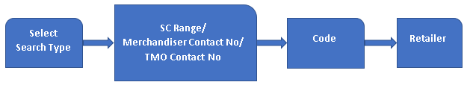

**Description:** The Above process demonstrates how a user will use the Smart Search feature.

**Figure: 7.2**

* **Select Search Type:** It is a dropdown menu feature to view the different search types.
* **SC Range:** It is an option of Select Search Type from the dropdown menu.
* **Merchandiser Contact No:** It is an option of Select Search Type from the dropdown menu.
* **TMO Contact No:** It is an option of Select Search Type from the dropdown menu.
* **Code:** It is a numeric field to enter a code to search specifically.
* **Search:** It is a feature to search for specific information.

**Rules/Validation:**

1. The Search Type dropdown menu options must be visible appropriately.
2. Users must be able to scroll through the menu options and able to select the required option by clicking on it.
3. If the search result is not matched or not found, Users must get a notification for that.

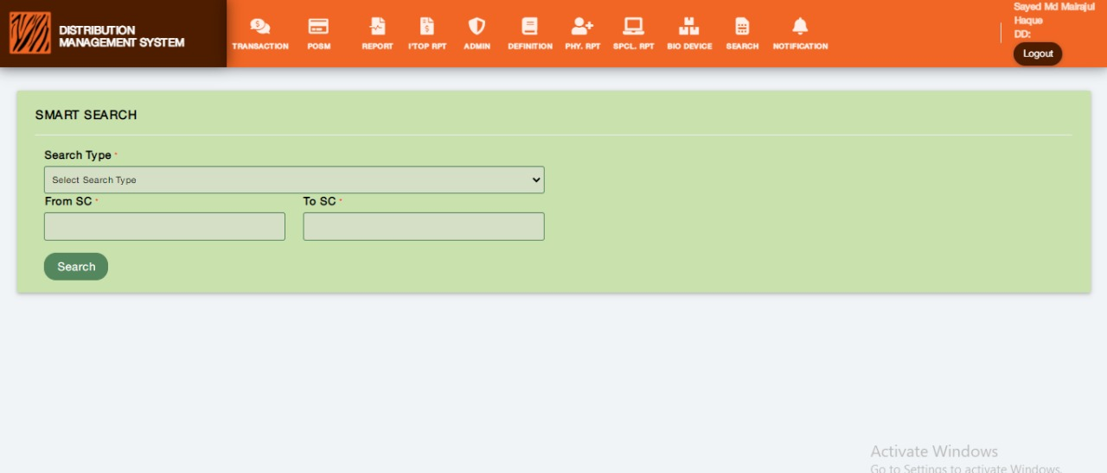**Figure: 7.3 Smart Search SC**

**Process:**



**Description:** The Above process demonstrates how a user will use the SC Range feature.

**Figure 7.3**

* **Select Search Type:** It is a dropdown menu feature to view the different search types.
* **From SC:** Users can input the starting SC in From SC field.
* **To SC:** Users can input the end SC in the To SC field.
* **Search:** It is a feature to search for specific information.

**Rules/Validation:**

1. The Search Type dropdown menu options must be visible appropriately.
2. From SC value must be smaller than TO SC value.
3. From SC and TO SC should be integer type value

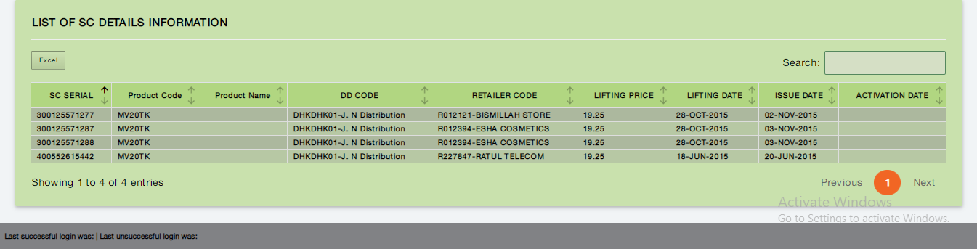**Figure: 7.4 List of SC Details**

**Process:**



**Description:** The Above process demonstrates how a user will view the Smart Search report.

**Figure: 7.4**

* **View:** Users can view the List of SC Details Information.
* **Excel Export:** Users can download the list information in an excel file by clicking the Excel Export button.
* **Search:** It is a feature to search for specific information.

**Rules/Validation:**

1. The list information and field name must show appropriately.
2. Excel Export format must be as same as a pre-defined format.

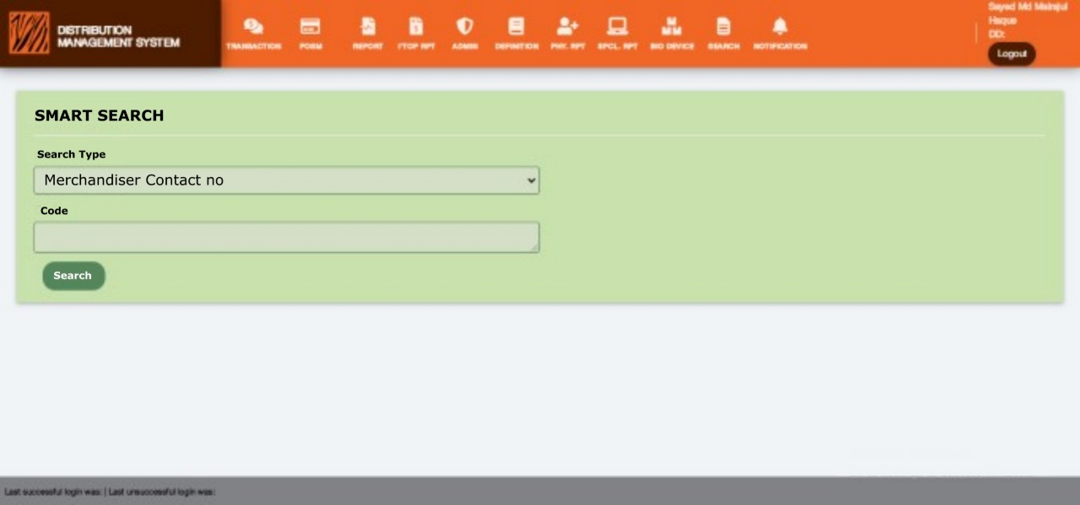**Figure: 7.5 Smart Search Merchandiser Contact no**

**Description:** The Above picture demonstrates how a user will use Merchandiser Contact no in the Search Type field.

Figure: 7.6

**Figure 7.6** The above picture shows the Merchandiser Contact no Information.

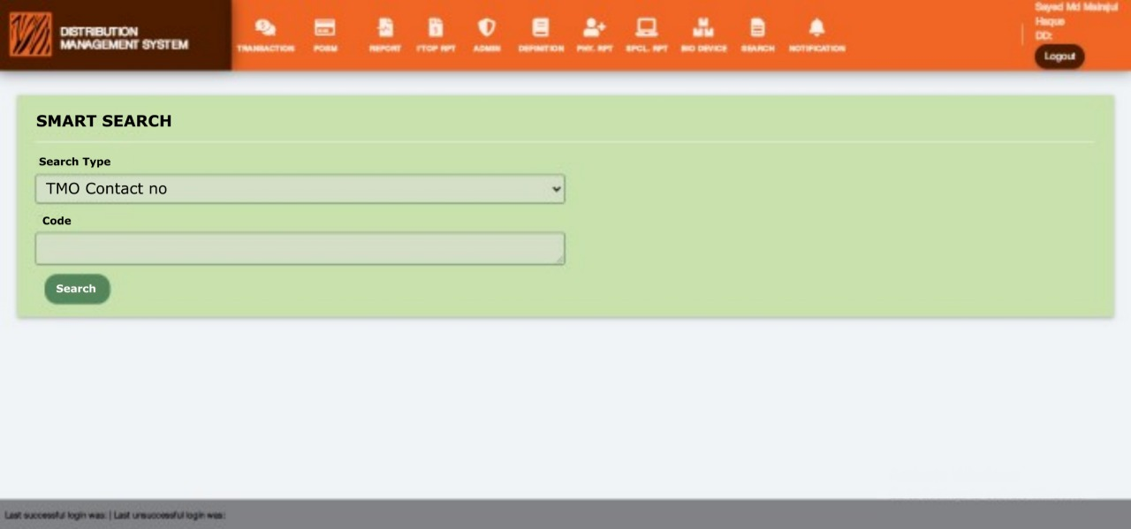**Figure: 7.7 Smart Search TMO Contact no**

**Description:** The Above picture demonstrates how a user will use TMO Contact no in the Search Type field.

**Figure:7.8**

**Figure 7.8** The above picture shows the TMO Contact no Information.

# FR 8- In Add/Edit Retailer Type.

**Reference:** FR 8 (DMS) (Business Recruitments Document)

**Functionalities:**

1. Introduce ZONECODE flagging.

Available Zone must be

(▪ ALTBAN

▪ BLKBLK

▪ KHLBAR

▪ COMSOU

▪ CHINOR

▪ CHISOU

▪ CTGMET

▪ COMNOR

▪ D2DDWT

▪ DEVNAT

▪ DHKEAS

▪ DHKSOU

▪ DHKWES

▪ DHKNAR

▪ DHKTAN

▪ DHKOUT

▪ DHAGAZ

▪ MYMMYM

▪ EBEEBE

▪ KHLKHL

▪ KHLKUS

▪ KHUJES

▪ SYLSYL

▪ RAJBOG

▪ BOGBOG

▪ RAJRAJ)

will load for each retailer type.

1. User will be able to assign zone codes for each type. Zone Code to Retailer Type relation is One to Many Relations.
2. In the retailer type of retailer page, retailer types will be available in the dropdown list as per the configuration above.
3. In Retailer add/edit Page - Retailer Type Dropdown will load According to logged Distributor's Zone Code.

Interfaces:

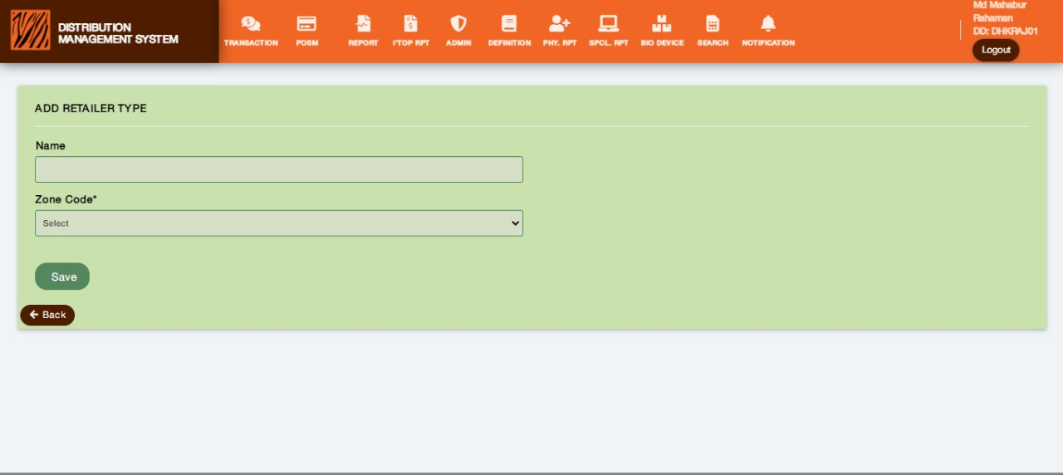 Figure: 8.1 Add Retailer Type

Process:

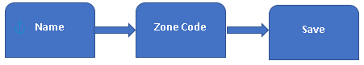

Description: The Above process demonstrates how a user will add retailer type.

Figure 8.1 Description:

* Add retailer Type: Users can add retailer type on this page.
* Name: Users must input retailer type name in the Name field.
* Zone Code: Users must input zone code in the Zone Code field.
* Save: After giving inputs user can save the information with the Save button.

**Rules/Validation:**

1. Retailer Type Name is a text field. It is a mandatory field. It must be unique.
2. Zone code is a dropdown selection field. It is also a mandatory field. Zone Code List load from Zone Table.
3. After saving the information users must get a confirmation message or notification.

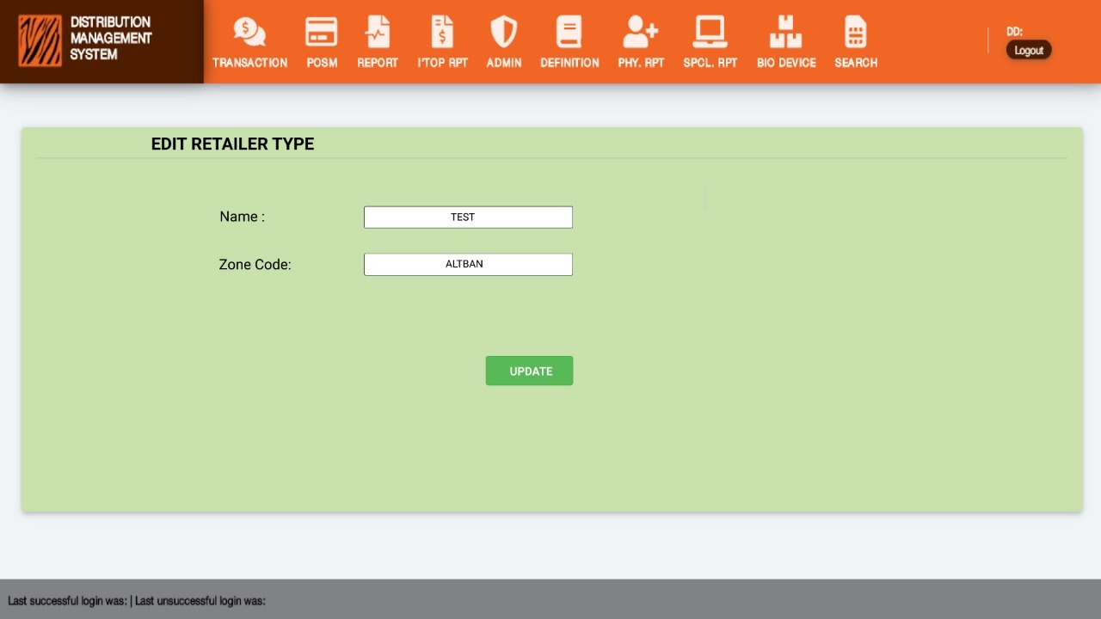Figure: 8.2 Edit Retailer Type

Edit Retailer Type Process:

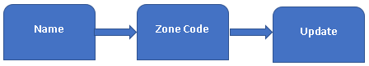

Description: The Above process demonstrates how a user will edit retailer type.

Figure 8.2 Description:

* Edit Retailer Type: Here, users can edit the retailer type.
* Name: Users will input the retailer’s new name in this field.
* Zone Code: Users will input the retailer’s new zone code in this field.
* Update: After editing and changing the information user can save the new information by clicking the update button.

**Rules/Validation:**

1. Retailer Type Name is a text field. It is a mandatory field. It must be unique.
2. Zone code is a dropdown selection field. It is also a mandatory field.
3. After saving the information users must get a confirmation message or notification.

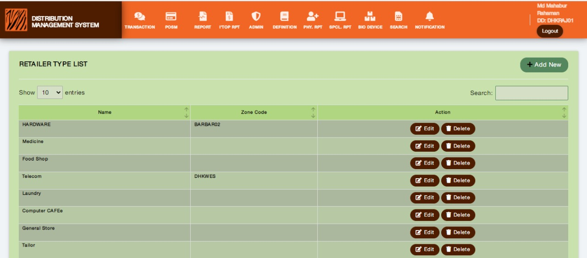 Figure: 8.3 Retailer Type List

Retailer Type List Process:



Description: The Above process demonstrates how a user will view, search, edit, and delete retailers from the retailer type list.

Figure 8.3 Description:

* RETAILER TYPE LIST: Users can see the saved retailer type list from add retailer type.
* Edit: Users can edit each specific row of information from this feature.
* Delete: Users can delete each specific row of information through this feature.
* Search: Users can search in Retailer Type List with specific information like Name, Zone Code.

**Rules/Validation:**

1. The list’s Row and Colum must not overlap with each other.
2. The list’s headers must be visible clearly.
3. Users must receive a confirmation notification when want to edit and delete any data from the list.
4. User must receive notification for invalid search data.

# FR 9- POSM Product

**Reference:** FR 9 (DMS) (Business Recruitments Document)

**Functionalities:**

1. **POSM Product Return with approval**
2. User returns products from retailer to DD
3. User chooses a product and enters count, the system validates floor count vs return count, submit return products from DD floor to WH; for success will be available in the pending list for approval, for failure error message with actual reason.
4. User approves return to WH.
5. Product is deducted from DD Floor.
6. A return report will be found. Distributor, product, count, return verified date.
7. **POSM Product Write-off with approval**
8. Write-off from the retailer.

* User chooses the product and enters count, the system validates floor count vs request count, submit write-off products; for success will be available in the pending list for approval, for failure error message with actual reason.
* User approves.
* Product is written–off.

1. Write-off from the distributor.

* User chooses a product and enters count, the system validates DD floor count vs request count, submit write-off products; for success will be available in the pending list for approval, for failure error message with actual reason.
* User approves.
* Product is written–off.

**Interfaces:**

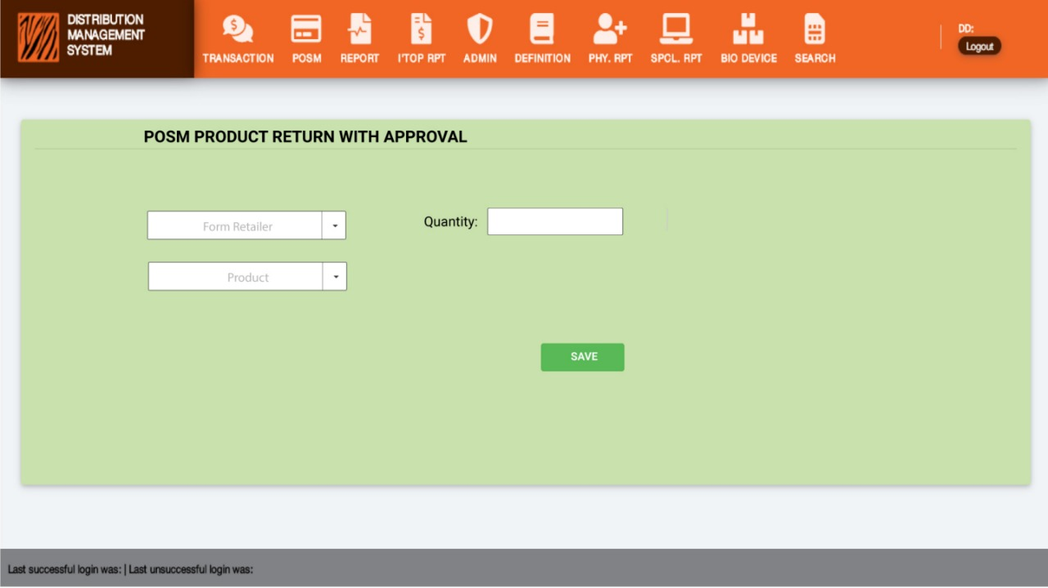**Figure: 9.1 POSM Product Return with Approval**

**Process:**

**Description:** The Above process demonstrates how a user will submit a return request for a POSM product for approval.

**Figure: 9.1**

* **From Retailer:** It is a dropdown feature to select the retailer from where the product is returning.
* **Product:** It is also a dropdown menu to select the specific product which is going to be returned
* **Quantity:** It is an input field where users can enter the quantity of the product.
* **Return:** Return is a submit button, after entering all required information user can submit the request by clicking the Return button.

**Rules/Validation:**

1. From Retailer must be selected.
2. Quantity must be provided.
3. Product must be selected.
4. Provided quantity for the selected product must be available on the retailer’s end.

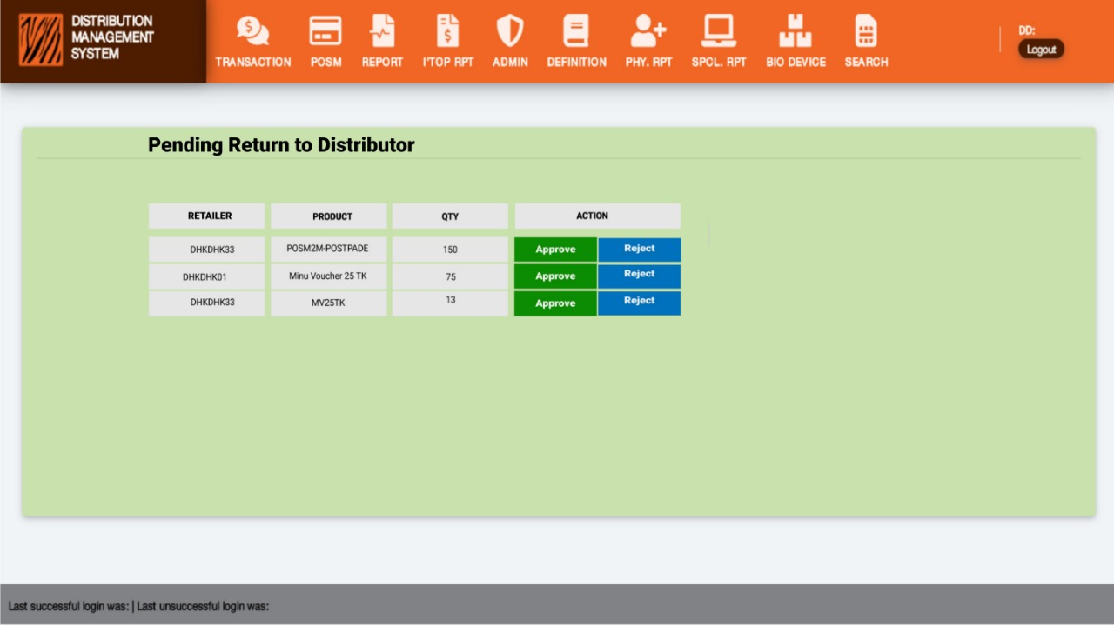**Figure: 9.2 For Distributor**

**Process:**



**Description:** The Above process demonstrates how a user will view the pending request for product return in Return to Distributor.

**Figure: 9.2**

* **Retailer:** It is a column name of Retailer in Return to Distributor List.
* **Product:** It is a field for product name in Return to WH list.
* **Quantity:** It is a field to show the product quantity.
* **Action:** It is an action field for approval of the pending request as Approve or Reject.

**Rules/Validation:**

1. Check if users can successfully approve/reject from the list.

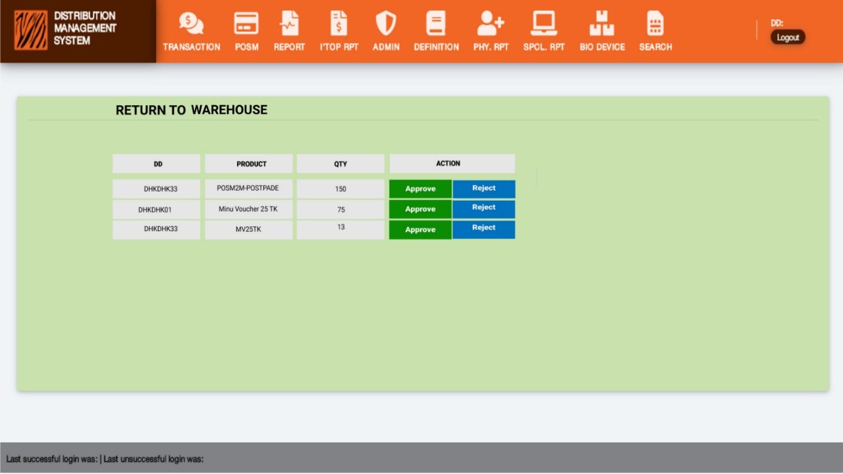**Figure: 9.3 For Distributor**

**Process:**



**Description:** The Above process demonstrates how a user will view the pending request for product return in Return TO WH.

**Figure: 9.3**

* **DD:** It is a column name of DD in Return to Warehouse list.
* **Product:** It is a field for product name in Return to WH list.
* **Quantity:** It is a field to show the product quantity.
* **Action:** It is an action field for approval of the pending request as Approve or Reject.

**Rules/Validation:**

1. Check if users can successfully approve/reject from the list.

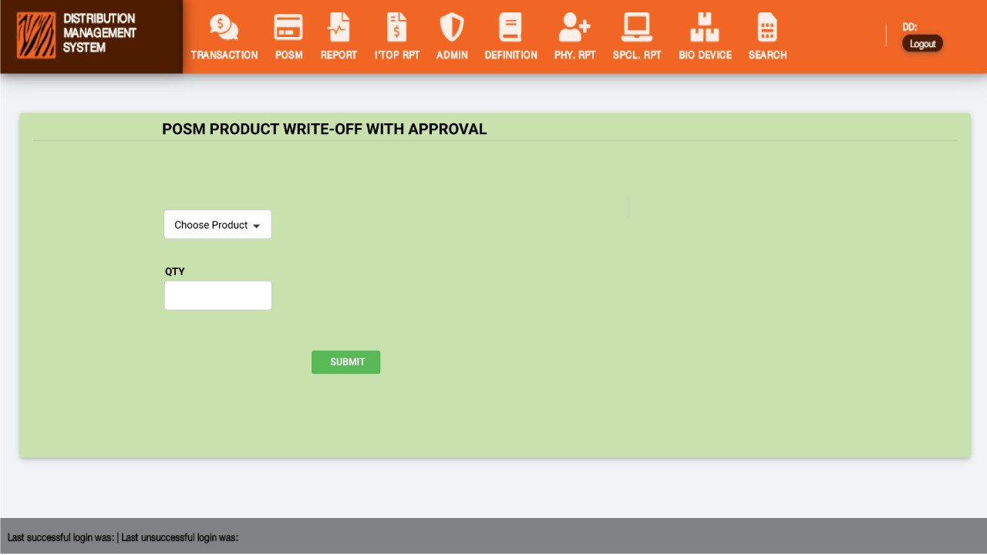**Figure: 9.4 POSM PRODUCT WRITE-OFF WITH APPROVAL for Distributor**

**Process:**



**Description:** The Above process demonstrates how a user will do POSM PRODUCT WRITE-OFF WITH APPROVAL.

**Figure: 9.4**

* **Choose Product:** It is a dropdown menu to choose a specific product.
* **Quantity:** It is an input field to enter the product quantity.
* **Submit:** It is a submit button to save the information.

**Rules/Validation:**

1. Product must be selected.
2. Quantity must be provided.
3. Provided quantity must be available on Retailer’s end.

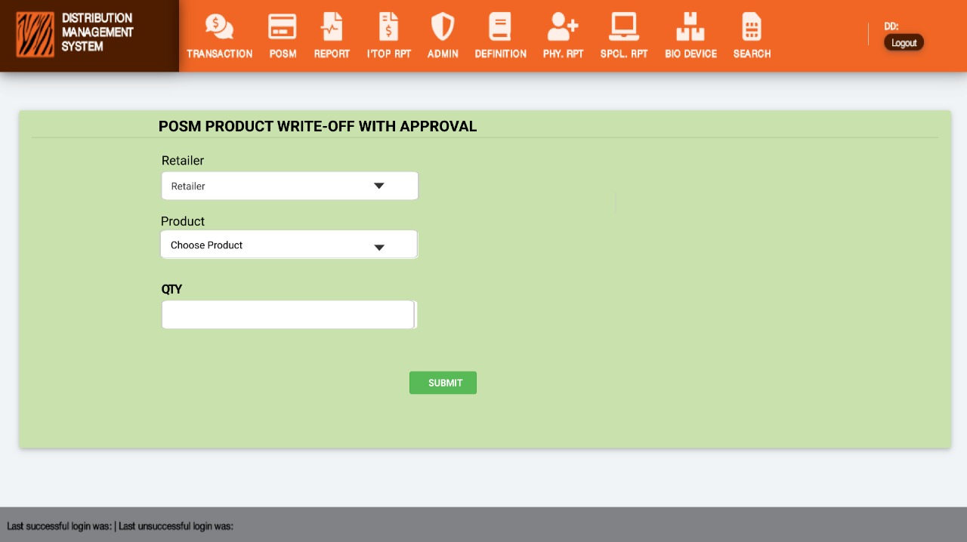 **Figure: 9.5 POSM PRODUCT WRITE-OFF WITH APPROVAL for Retailer**

**Process:**



**Description:**

**Figure 9.5:**

**Rules/Validation:**

1. Product must be selected.
2. Quantity must be provided.
3. Provided quantity must be available on the Distributor’s end.

# FR 10- Change in ISSUE TO RETAILER, RECEIVE DEVICE FROM RETAILER: include Retailer search.

**Reference:** FR 10 (DMS) (Business Recruitments Document)

Functionalities:

1. **Include Retailer search in the dropdown:** Pages ISSUE TO RETAILER, RECEIVE DEVICE FROM RETAILER.
2. Show in the below section available devices for the selected retailer.

Fields: Retailer code, Device Name, Device Code, Issue Date, Serial, Status.

1. Include a new field “Description” on the DEVICE STOLEN INFO page.
2. **Audit Report Product Wise**: Cluster, Region, Distributor Code, Distributor Name, Device Name, Device Code, Receiving Date from WH, Total Devices, Distributor Floor count, Issue to Retailer count, Device faulty count, Device Stolen count, Returned to WH (intact), Returned to WH (faulty), Migrated to other DD, return-reissue to retailer count.

Filter: Device Name, Cluster, Region, Distributor.

(Internal as per role)

1. **Audit Report Summary**: Cluster, Region, Distributor Code, Distributor Name, Distributor Active Status, Disabled Date, Total Devices, Distributor Floor count, Issue to Retailer count, Device faulty count, Device Stolen count, Returned to WH (intact), Returned to WH (faulty), Migrated to Other DD, return-reissue to retailer count.

Filter: Cluster, Region, Distributor.

(Internal as per role)

1. **Device Overview Report:** Distributor Code, Device Name, Device Code, Receiving Date from WH, Total Devices, Distributor Floor count, Issue to Retailer count, Device faulty count, Device Stolen count, Returned to WH (faulty),

(External as per role)

1. **Migrated Report**:

Device Code, Name, Serial, Date, From Distributor, To Distributor, Reason.

1. Process Flow:
2. Distributor Receive from WH.
3. Received items will be at Distributor Inventory.
4. Issue device to Retailer from distributor inventory (the counter will be included).
5. Mark as Stolen/Lost (must be issued to retailer state).
6. Return Device from Retailer to Distributor inventory (the counter will be included)

(Select from Dropdown reason: Reissue to Other, Faulty/Damaged).

1. Return to WH (Select from Dropdown reason: Intact, Faulty).
2. Migrate from Distributor to Other Distributor.

**Interfaces:**

**Process:**

**Rules/Validation:**

# FR 11- Mark retailer’s device as faulty/damaged (Same Process of marking sim as faulty.)

**Reference:** FR 11 (DMS) (Business Recruitments Document)

Functionalities: Faulty/damaged device return to WH

1. Go to Device return to WH.
2. All faulty marked devices will be available for return.
3. Select return to WH.
4. The request will be pending ZM approval.
5. On ZM approval the devices will be marked as returned to WH.
6. A returned to WH Device list (excel export) will be generated, without any filter. Format: Distributor, Serial, product code, Issue date, Return date.

**Interfaces:**

**Figure: 11.1**

**Process:**

**Description:** The Above process demonstrates how a user will Mark a retailer’s Device as Faulty/Damaged.

**Figure: 11.1**

* **Provide Date:** The date will be auto-selected or User-defined.
* **Select Retailer:** Retailers Dropdown List.
* **Provide Device IMEI List:** It is an input field, Users can enter the device list and details in the Device List field.
* **Save:** Users can save the input information by clicking the Save button.

**Rules/Validation:**

1. Date must be selected.
2. Retailer must be selected.
3. Each device IMEI must be a valid IMEI.
4. Device must be available on the DD floor.

**Figure: 11.2** **Pending Faulty device return to the warehouse**

**Process:**

**Description:** The Above process demonstrates how a user will view and operate the Pending Faulty device return to the warehouse.

**Figure: 11.2**

**Rules/Validation:**

1. Clicking on the ‘Return to WH’ button will show a success/failure message.

**Figure: 11.3 Pending Faulty Device Return to Warehouse**

**Process:**

**Description:** The Above process demonstrates how a user will view and operate Pending Faulty Device Return to Warehouse.

**Figure: 11.3**

**Rules/Validation:**

1. User can accept/reject a device from the list.
2. Clicking on the ‘Accept/Reject’ button will show a success/failure message.

|  |  |  |  |  |
| --- | --- | --- | --- | --- |
| Distributor | Serial | product code | Issue date | Return date |
|  |  |  |  |  |
|  |  |  |  |  |

**Figure: 11.4**

# FR 12- User Response and Feedback capturing.

**Reference:** FR 12 (DMS) (Business Recruitments Document).

Functionalities: User Response and Feedback capturing

1. Users will be able to visit the **Feedback** page on every page to log feedback.
2. Page URL and Date will be captured automatically (SYSDATE).
3. Rating will be introduced during feedback (1-10 with emoji 😊 ☹) with a text box field opening for low Rating.
4. 5 categories will be rated (User-friendly, Smooth Operations, faster response, useful content, interactive) with a checkbox for multiple choice.
5. General Feedback open-ended (Bangla and English) for each.
6. For 1-4 Open fields will appear to provide the reason in detail: we are sorry to hear that, please share the reason in detail for our improvement. (In Bangla and English)

In Admin section

**Feedback Report:**

User Id, User Name, Distributor Code, Date, Rating, category, Feedback Flag (Good (8-10), IN (1-4)), General Feedback, Reason.

**Interfaces:**

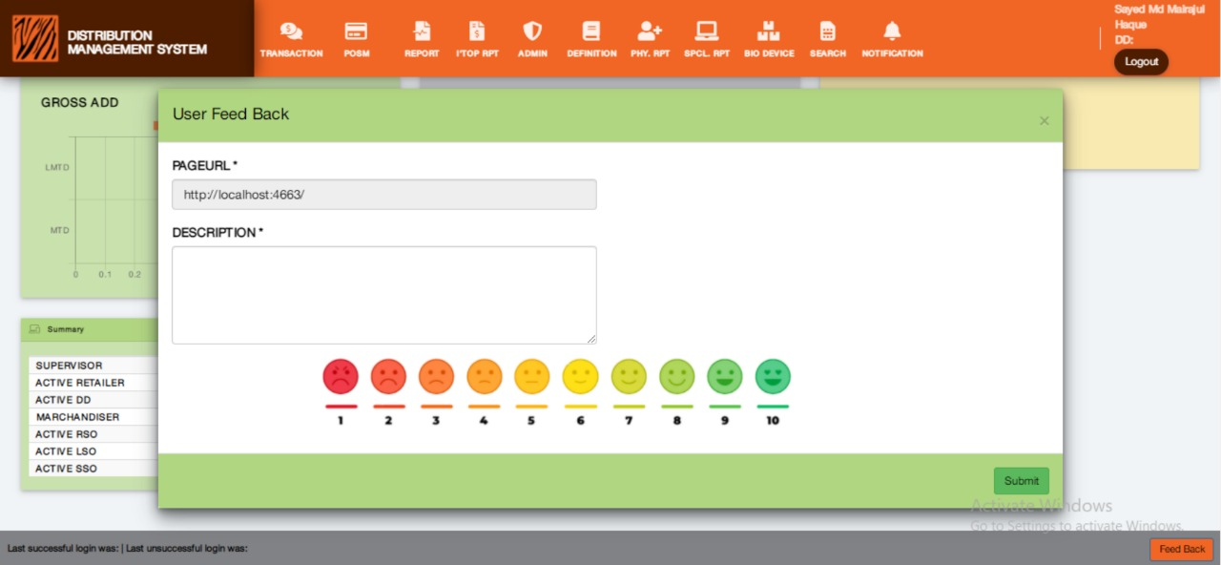**Figure: 12.1 User Feedback (Start Page)**

**Description:** The Above picture demonstrates how a user will view the User Feedback page.

**Process:** The below process demonstrates how a user will submit feedback through User Feedback feature.

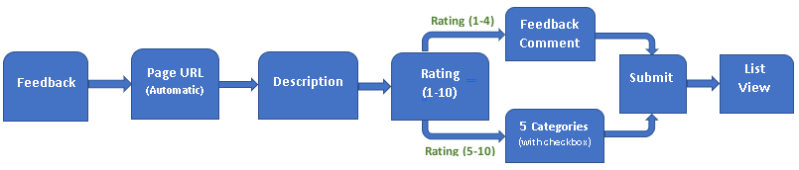

**Figure 12.1**

1. **Feedback:** It is a button on every page in the bottom right position. Users can start the process of giving feedback by clicking on this button.
2. **Page URL:** It is a link for the page on which page user is giving his/her feedback. It generates automatically.
3. **Rating:** Users can start the feedback by clicking on 1-10 on any rating option. This is a mandatory field.
4. **Description:** Users can write down the basic details in the Description text box. It is a mandatory field.
5. **Submit:** Users can save the responses by clicking on Submit button.

**Rules/Validation:**

1. Users must have to select any rating from 1 to 10.
2. Users must write some details in the Description.

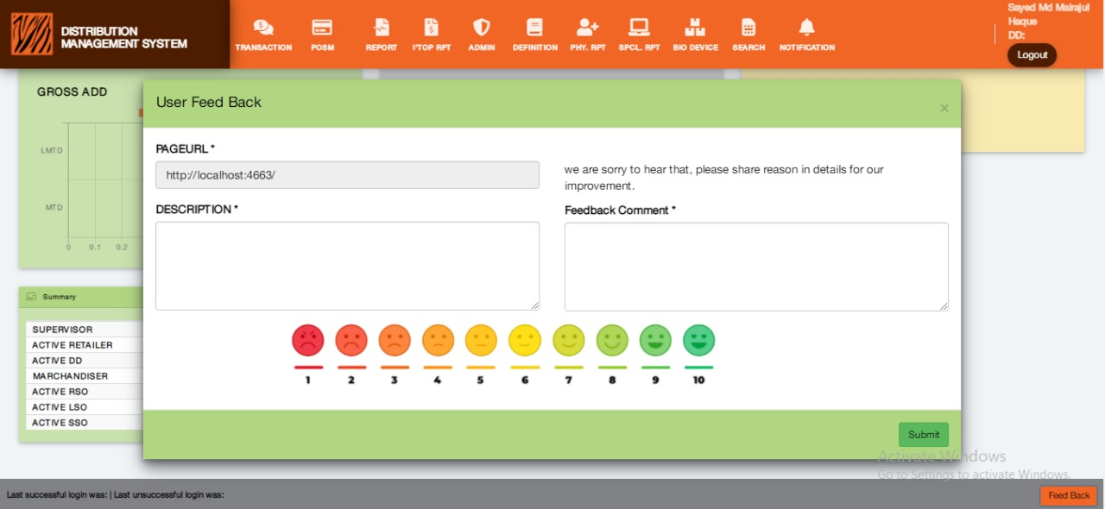**Figure: 12.2 User Feedback (Rating 1-4)**

**Description:** The Above picture demonstrates how a user will give a Rating of (1-4 low) in User Feedback.

**Figure 12.2**

1. **Feedback:** It is a button on every page in the bottom right position. Users can start the process of giving feedback by clicking on this button.
2. **Page URL:** It is a link for the page on which page user is giving his/her feedback. It generates automatically.
3. **Rating:** Users can start the feedback by clicking on 1-10 on any rating option. This is a mandatory field.
4. **Description:** Users can write down the basic details in the Description text box. It is a mandatory field.
5. **Reason in Detail:** In rating, if users click on 1-4 then an input text field with “we are sorry to hear that, please share the reason in detail for our improvement” message will appear. It is a mandatory field.
6. **Submit:** Users can save the responses by clicking on Submit button.

**Rules/Validation:**

1. Users must have to select any rating from 1 to 4 for giving the low rating response.
2. Users must write some details in the Description.
3. Reason in Details is a mandatory field.

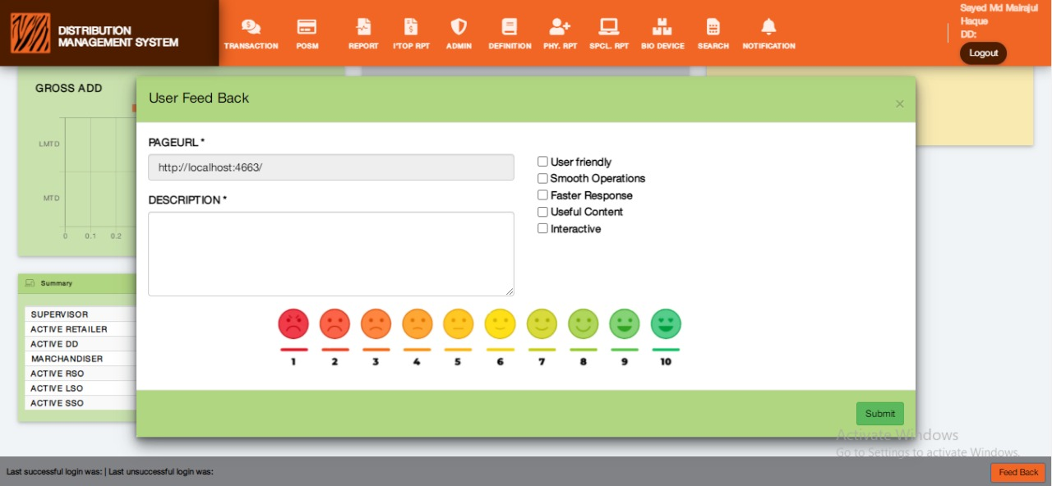**Figure: 12.3 User Feedback (Rating 5-10)**

**Description:** The Above picture demonstrates how a user will give a Rating of (5-10 high) in User Feedback.

**Figure 12.3**

1. **Feedback:** It is a button on every page in the bottom right position. Users can start the process of giving feedback by clicking on this button.
2. **Page URL:** It is a link for the page on which page user is giving his/her feedback. It generates automatically.
3. **Rating:** Users can start the feedback by clicking on 1-10 on any rating option. This is a mandatory field.
4. **Description:** Users can write down the basic details in the Description text box. It is a mandatory field.
5. **Categories:** In rating, if users click on 5-10 then 5 categories (User-friendly, Smooth Operations, Faster Response, Useful content, Interactive) with checkboxes for multiple select will appear. At least choosing one option from 5 categories is mandatory.
6. **Submit:** Users can save the responses by clicking on Submit button.

**Rules/Validation:**

1. Users must have to select any rating from 5 to 10 for giving a high rating response.
2. Users must write some details in the Description.
3. At least choosing one option from 5 categories is mandatory.

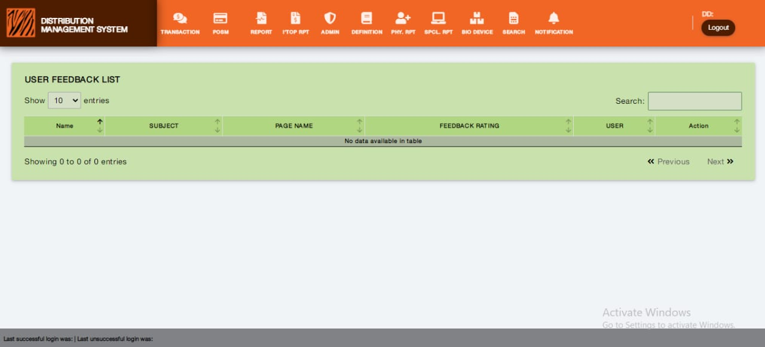**Figure: 12.4 User Feedback List**

**Description:** The Above picture demonstrates how a user will view the User Feedback List.

**Rules/Validation:**

1. Check that each row of the list show valid information

# FR 13- Site-wise KPI report in DMS (l KPI by admin user).

**Reference:** FR 13 (DWH+DMS) (Business Recruitments Document)

**Functionalities:**

Existing logic, in external KPI, will be lesser, in internal full view.

Filter Date, Thana.

Interfaces:

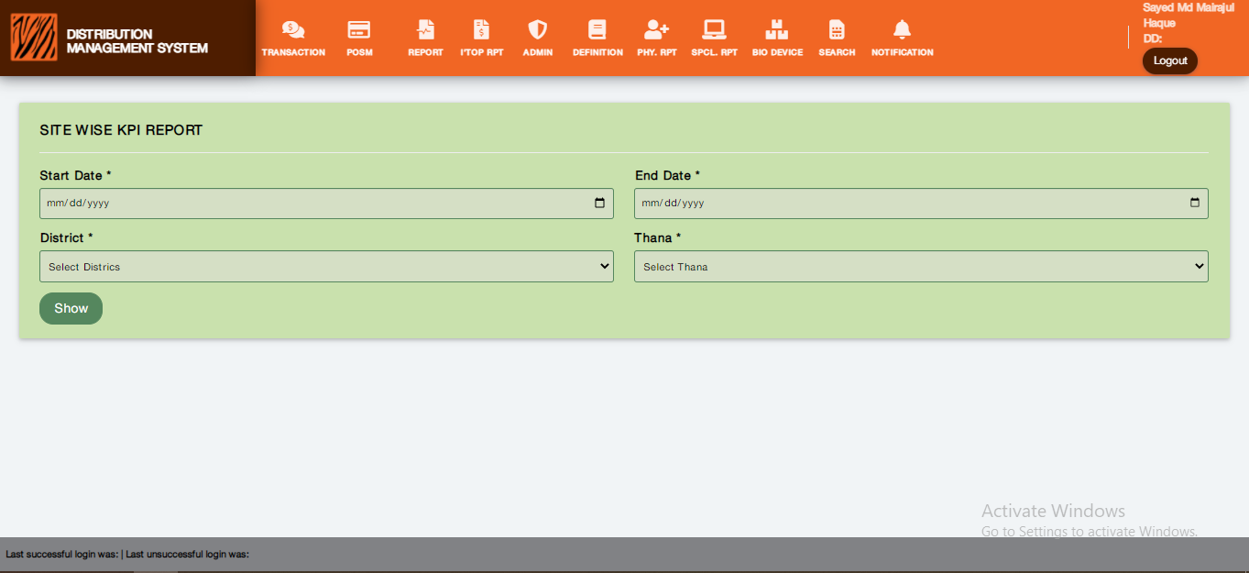Figure: 13.1 Site wise KPI Report

**Process:**



Description: The Above process demonstrates how a user will view Site Wise KPI Report.

Figure 13.1 Description:

* **Start Date:** Users enter the start date for the report in the Start Date field. It is a mandatory field.
* **End Date:** Users enter the end date for the report in the End Date field. It is a mandatory field.
* **District:** Users can select a specific district by clicking District and then selecting from the dropdown. It is a mandatory field.
* **Thana:** Users can select specific thana by clicking thana then selecting from the dropdown. It is a mandatory field.
* **Show:** Users can view the report by clicking the Show button.

**Rules/Validation:**

1. Start date is a mandatory field. It must pop up a calendar after clicking on it.
2. End date is a mandatory field. It must pop up a calendar after clicking on it.
3. Thana is a mandatory field.
4. Any button or input fields must not be overlapped, broken, or mismatched.
5. Error messages must be visible and specific.

# FR 14- Deno Checking daily User count (9133).

**Reference:** FR 14 (DMS) (Business Recruitments Document).

Functionalities:

1. MSISDN, Date, Deno, Count of request.
2. Filter: From Date- To Date, Deno
3. Admin module, Internal and only exposed to Admin.

**Interfaces:**

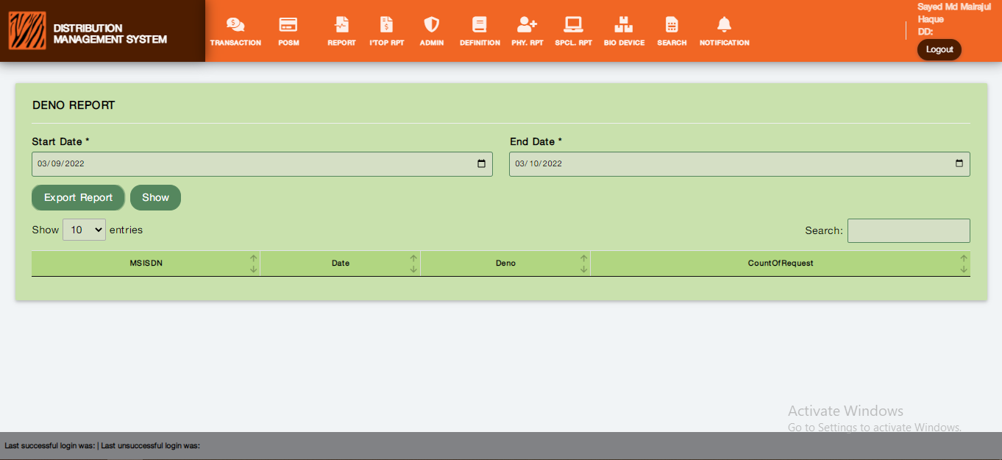**Figure 14.1 Deno Report**

**Process:**



**Description:** The Above process demonstrates how a user will view Deno Report and Export Report in Excel.

**Figure 14.1**

**Rules/Validation:**

* **Search:** Users search for information with this feature.
* **Start Date:** Users enter the Start Date for the report in this field. It is a mandatory field.
* **End Date:** Users enter the End Date for the report in this field. It is a mandatory field.
* **Show:** Users view the information in a list by clicking the Show button after entering valid information.
* **Export Excel:** Users can download the report in excel format by clicking Export Excel.

# FR 15- Site wise report revamp (both mail communication and DMS new report FR#13)

**Reference:** FR 15 (DWH+DMS) (Business Recruitments Document)

NO User Interfaces Required.

**Functionalities:**

1. Include 4G data and information.
2. Include Site information.
3. Include new KPI.
4. Tracking on report read.

Condition: Source will be DWH & DMS.

Interfaces:

**Rules/Validation:**

# FR 16- SRAN Site Tagging option in BTS site list of DMS

**Reference:** FR 16 (DMS) (Business Recruitments Document)

**Functionalities:**

1. SRAN Site Tagging option in BTS site list of DMS
2. Include SRAN Flag in Site wise reports FR 13 and FR 15.
3. In BTS ADD, EDIT, and BTS BULK upload page include SRAN Flag.

Interfaces:

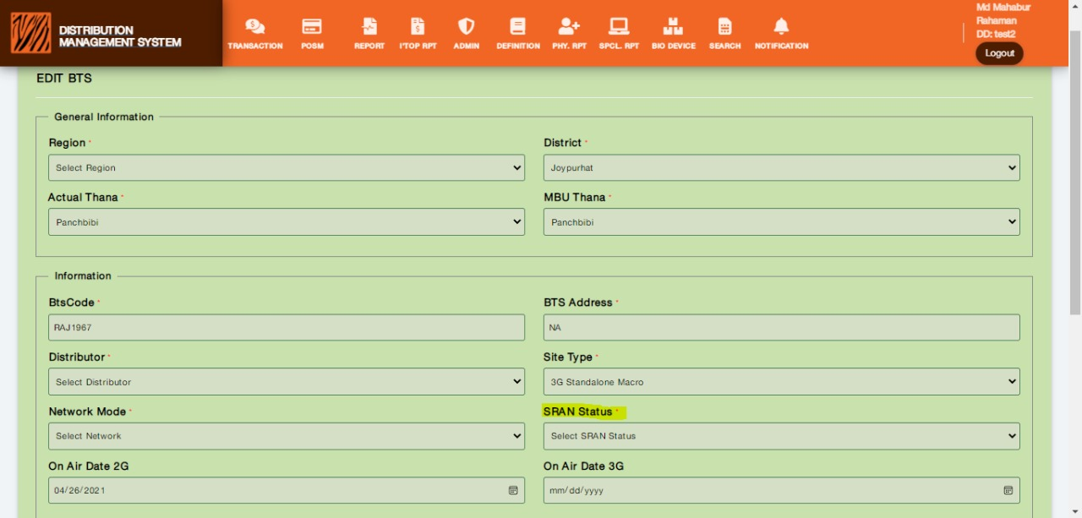Figure 16.1 SRAN Status

Process:



Description: The Above process demonstrates how a user will set SRAN Status.

Figure 16.1:

* SRAN Status: It is a new dropdown field with input data of Yes/No.

**Rules/Validation:**

1. Check that the newly added SRAN Status works as per process.

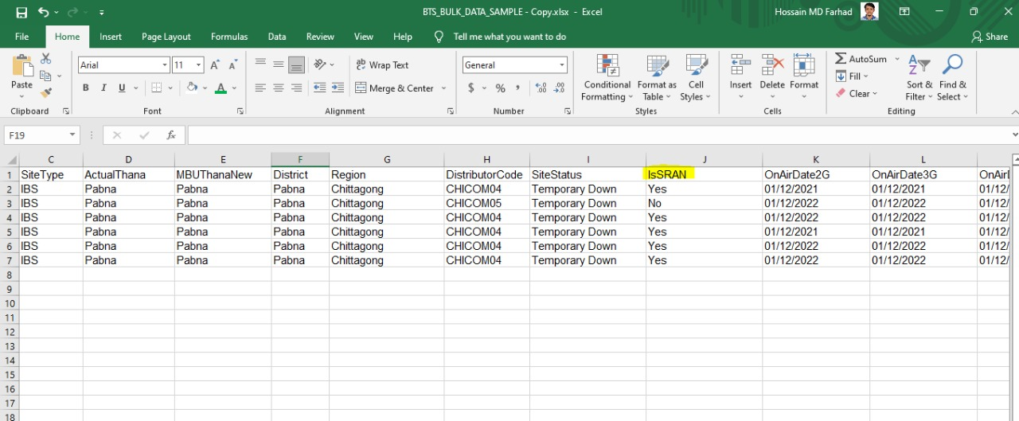Figure 16.2 IsSRAN Colum

**Figure 7.1 & 7.2 Description:** SRAN Site Tagging option in BTS site list of DMS. IsSRAN input field in excel file upload system.

**Rules/Validation:**

1. SRAN Status must be visible with a drop-down of the Yes or No option.
2. Add IsSRAN in excel file format for bulk uploading
3. SRAN status must be selected.

# FR 17- Retailer Database (Internal, External, and Dump) revamp.

**Reference:** FR 17 (DMS) (Business Recruitments Document).

No User Interfaces Required.

**Functionalities:**

1. Include fields (retailer TIN, Disable / terminated Date, Terminated (Y/N), First Verified, Last Verified, Reason 1, Reason 2).
2. DUMP issue resolve

* Heads are broken to next line: RSO_CODEBTS_CODE route1 route2 route3 route4 route5 route6 route7 route8
* Address spaces impacted next record, handle in exports.
* Blanks in record

**Interfaces:**

**Process:**

**Rules/Validation:**

# FR 18- Redesign Merchandiser structure.

**Reference:** FR 18 (DMS+RSO) (Business Recruitments Document).

**Functionalities:**

1. Add Designation in Merchandiser. (Requirement Delicacy Found in FR 18 & FR 22)
2. Add Select “ID TYPE” Select from dropdown NID, Birth Certificate, Alternate ID from the dropdown.
3. Edit NID Field; rename as Identification.
4. For NID, NID validation will be applicable for others NID validation will not be applicable.

**Interfaces:**

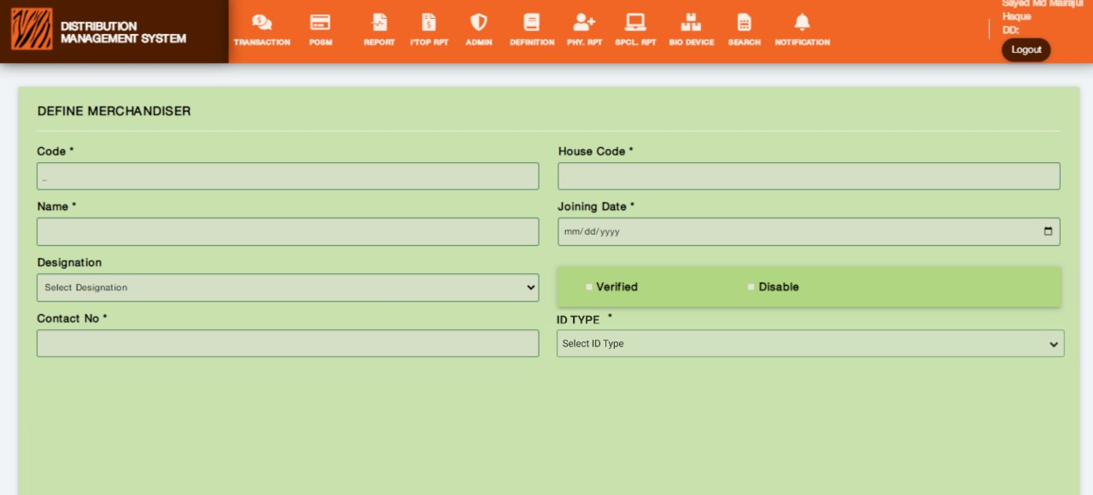**Figure: 18.1 Define Merchandiser (ID Type)**

**Process:**

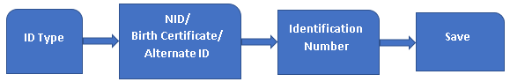

Description: The Above process demonstrates how a user will select ID Type, Input Identification Number, and Save the Data.

**Figure 18.1**

1. **ID Type:** Users can select ID Type by clicking on ID Type. It is a mandatory field.
2. **NID/Birth Certificate/Alternate ID:** Users can choose from NID or Birth Certificate or Alternate ID from the ID Type dropdown. It is a mandatory field.
3. **Identification Number:** After selecting an option of NID or Birth Certificate or Alternate ID from the ID Type dropdown another input field will come as “Identification Number”. Uses can input the preferred number in it.
4. **Save:** Users can save the input information by clicking on the Save button.

**Rules/Validation:**

1. For NID Numbers the length must be (17/13/10) digits only.7/13/10) digits only.
2. Identification Number input field must take integer number values.

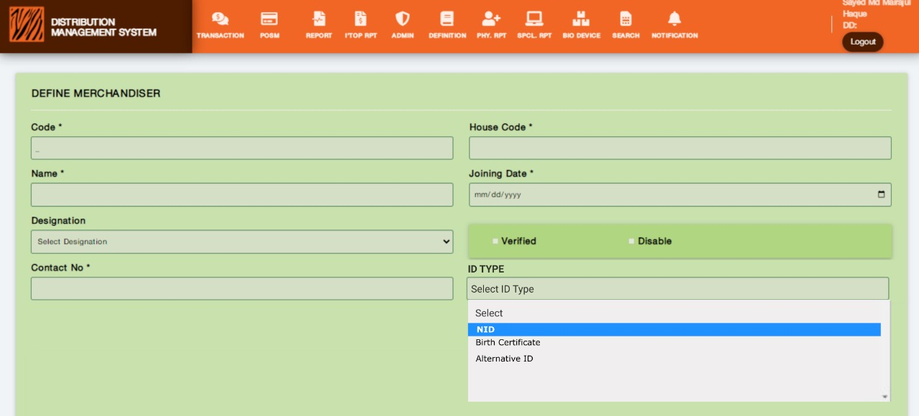Figure: 18.2 Define Merchandiser (ID Type- NID, BC, Alternate ID)

Description: The Above picture demonstrates how a user will select NID or Birth Certificate or Alternate ID from the ID Type dropdown.

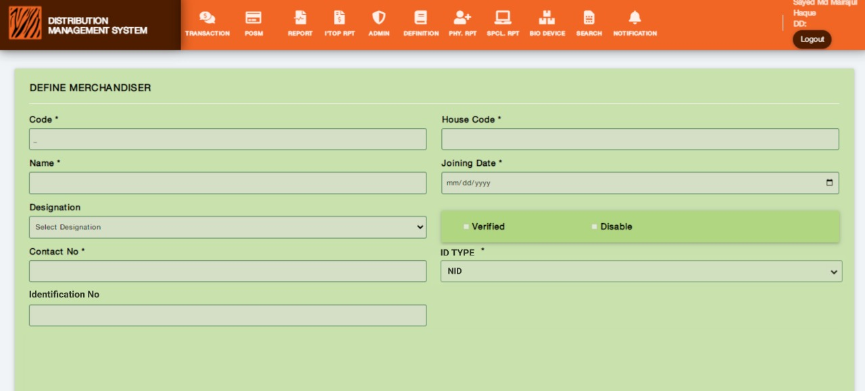**Figure: 18.3 Define Merchandiser (Identification No)**

Description: The Above picture demonstrates how a user will input values in Identification Number after selecting NID or Birth Certificate or Alternate ID from the ID Type dropdown.

# FR 19- DMS Dashboard Revamp

**Reference:** FR 19 (DMS) (Business Recruitments Document)

**Functionalities:** Dashboard Graph and Information Revamp.

1. Include active route count, On-Air BTS count in Summary.
2. Include dates instead of 1-7 days, in 3 boxes of “Last 7 days”, include today for 3 KPIs, and update live data.
3. Rename Summary as Distributor Summary.
4. Stock Summary

Current Inventory Prepaid

Current Inventory Post Paid

Current Inventory Scratch card

Channel Fill Prepaid

Channel Fill Post-paid

Channel Fill Scratch Card

1. Device Summary:

Total Scanner Count

Total TAB / Handset Count

Distributor Floor TAB count,

Distributor Floor Scanner count,

The issue to Retailer count,

Device faulty count,

Device Stolen count,

Returned to WH (faulty).

1. One new row of 3 items (target vs Achievement)

Prepaid MTD Target vs MTD achievement, LM Achievement with CR and RR

C2S MTD Target vs MTD achievement, LM Achievement with CR and RR

Total Bundle Target vs achievement with CR and RR (Data, Mixed, Voice)

Apply line graph (reference vFocus).

Interfaces:

**Rules/Validation:**

# FR 20 (DMS)- In BTS Information, the inclusion of Bangla Fields

(Address, Thana, District, Division Include missing 4,5 fields)

**(As discussed with business, this FR is removed)**

# FR 21- Weekly Update (Generate Report).

**Reference:** FR 21 (DMS) (Business Recruitments Document).

**Functionalities:**

1. KPI (Retailer, RSO, BTS, DD, Supervisor, Merchandiser).
2. Select Week (last 4 weeks) W1 (Jan1 – Jan7)-W52 (dec25-dec31)
3. Press Generate feature.
4. In KPI information Format: Year, Week, Type (KPI), New Count, Edit Count.
5. Multiple Week Information download feature.
6. Excel Export Report Feature.

**Interfaces:**

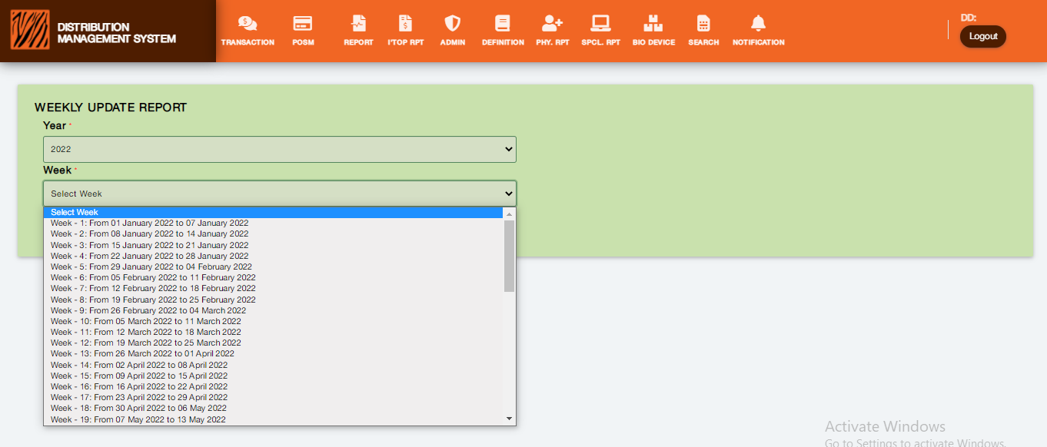**Figure: 21.1 Weekly Update (Generate report)**

Description: The Above picture demonstrates how a user will view and select a week in Weekly Update (Generate Update)

1. **Select Week:** Users can select the required week by clicking the Select Week dropdown menu.
2. **Generate:** Users can generate a report after selecting the required week by clicking Generate button.

**Rules/Validation:**

1. Users must select Year and Week. Both are mandatory fields.

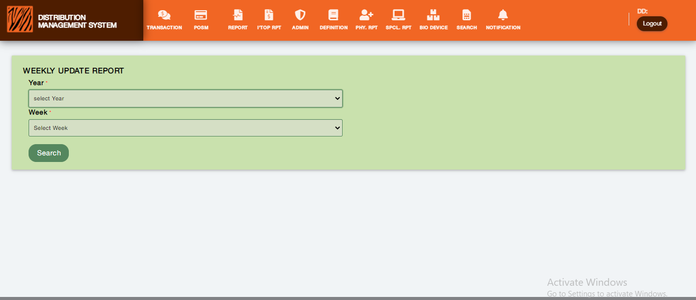**Figure: 21.2 Weekly Update (Generate report) Select Week**

Description: The Above picture demonstrates how a user will generate a report after selecting a Year and Week.

# . FR 22- In the Merchandiser, the New/Edit page includes the Designation column.

**Reference:** FR 22 (DMS + RSO) (Business Recruitments Document)

**Functionalities:**

1. In the Merchandiser New/edit page include the Designation column Field as a Dropdown menu.
2. Merchandiser Attendance details report from MDMS. Merchandiser Code, Contact number, retailer code, and product code, Qty, date, Check-in time, Checkout time, and time spent. Filter date.
3. Merchandiser Attendance Summary Report: Merchandiser Code, contact number, retailer count, Qty, date, total time spent. Filter date.

Interfaces:

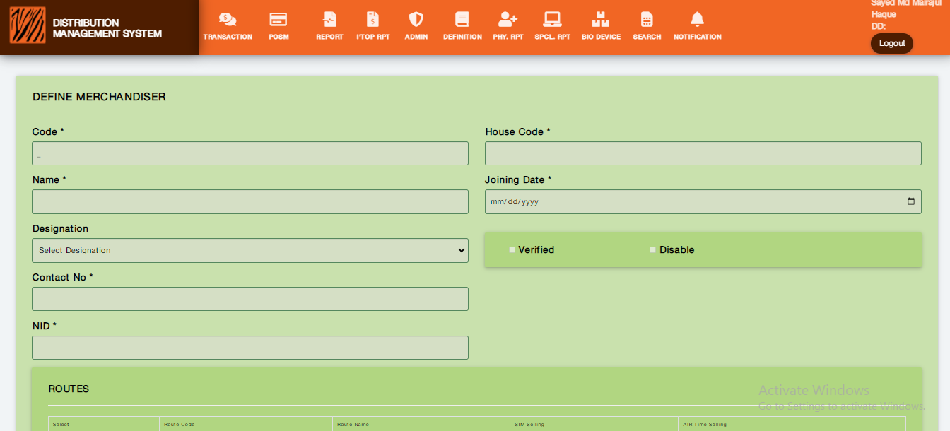

Figure: 22.1 Define Merchandiser

Define Merchandiser Process:

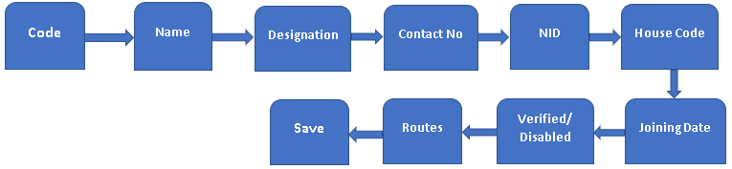

Description: The Above process demonstrates how a user will define a merchandiser with designation and save the information with mapping of routes.

* DEFINE MERCHANDISER: Users can add information about merchandisers in this feature.
* Code: Users can input code in the “Code” field. This is a mandatory field.
* Name: Users can input Merchandiser’s name in the “Name” field. This is a mandatory field.
* Designation: This feature comes as a dropdown menu for the user to select the preferred designation for the Merchandiser in this field. This is a mandatory field. Designation names are pre-defined and loaded from the new Designation Names table.
* Contact No: Users can input Contact No in the “Contact No” field. This is a mandatory field.
* NID: Users can input NID in the “NID” field. This is a mandatory field. The NID length must be 10/13/17.
* House Code: Users can input the House Code in the “House Code” field. This is a mandatory field.
* Joining Date: This feature comes with a calendar option to pick a joining date of the merchandiser or can be written manually by the user. This is a mandatory field. The user should not be able to enter the future date.
* Verified/Disabled Check Box: Users can check the Verified or Disabled check box for the specific merchandiser.
* Routs: Users can check/tick the required routes with a specific merchandiser when saving.
* Save: Users can save all the given input information by clicking the save button.

**Rules/Validation:**

1. NID length must be within (10,13,17) and Alphanumeric not allowed, only numbers are valid.
2. Users must get a notification/message after clicking the save button.
3. Joining date must be today’s date or the previous date. Should not be a future date.
4. Contact no length must be 11 digits of only integer number values.

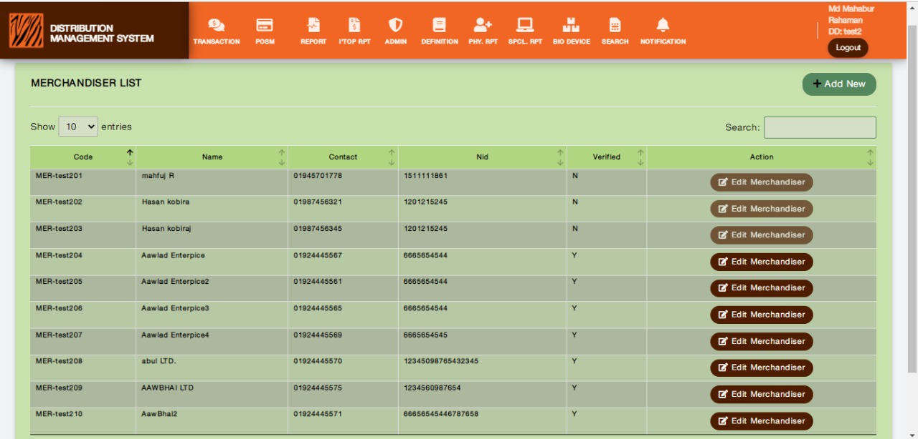**Figure: 22.2 Merchandiser List**

Figure 22.2 Description: The Above picture demonstrates how a user will View, Edit, and Search the Merchandiser List.

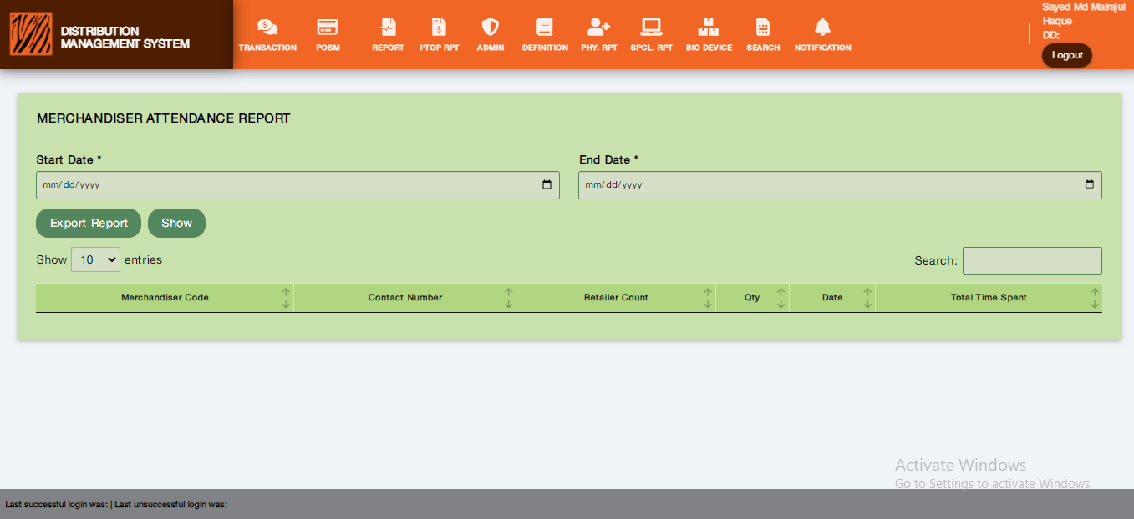Figure: 22.3 Merchandiser Attendance Report

Process:



Description: The Above process demonstrates how a user will view Merchandiser Attendance Report.

Figure: 22.3 Description

* **Start Date:** Users enter the start date for the report in the Start Date field. It is a mandatory field.
* **End Date:** Users enter the end date for the report in the End Date field. It is a mandatory field.
* **Export Report:** Users can download the report by clicking the Export Report button.

**Rules/Validation:**

1. Start date is a mandatory field. It must pop up a calendar after clicking on it.
2. End date is a mandatory field. It must pop up a calendar after clicking on it.
3. Any button or input fields must not be overlapped, broken, or mismatched.
4. Error messages must be visible and specific.
5. After clicking the Export Report button, the report must be downloaded automatically in pre-defined excel format.

# . FR 23- EV balance return option in DMS.

**Reference:** FR 23 (DMS) (Business Recruitments Document).

**Functionalities:** EV balance return option in DMS.

**Interfaces:**

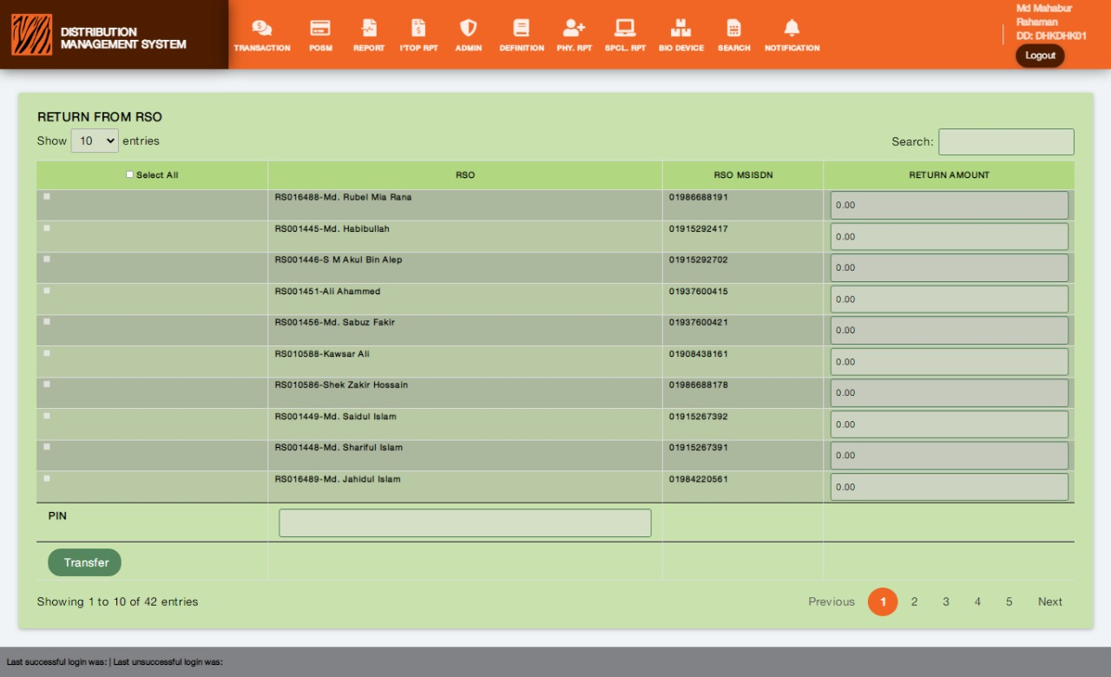**Figure: 23.1 Return FROM RSO**

**Process:**



**Description:** The Above process demonstrates how a user will operate the Return from RSO feature.

**Figure: 23.1**

* **View List:** Users can view the information in the list in Return from the RSO interface.
* **Select From Check Box:** Users can select all rows or can select individually by checking the check box.
* Enter Return Amount for the Selected RSO: User

**Rules/Validation:**

1. Check box must be selected for the desired RSO.
2. Return Amount must be provided for the selected RSO.
3. Return Amount must be greater than 0.
4. Return will be successful if the amount is less than or equal to RSO’s real-time balance on EV requested moment.
5. For the return amount which is requested through the RSO app can’t be edited.

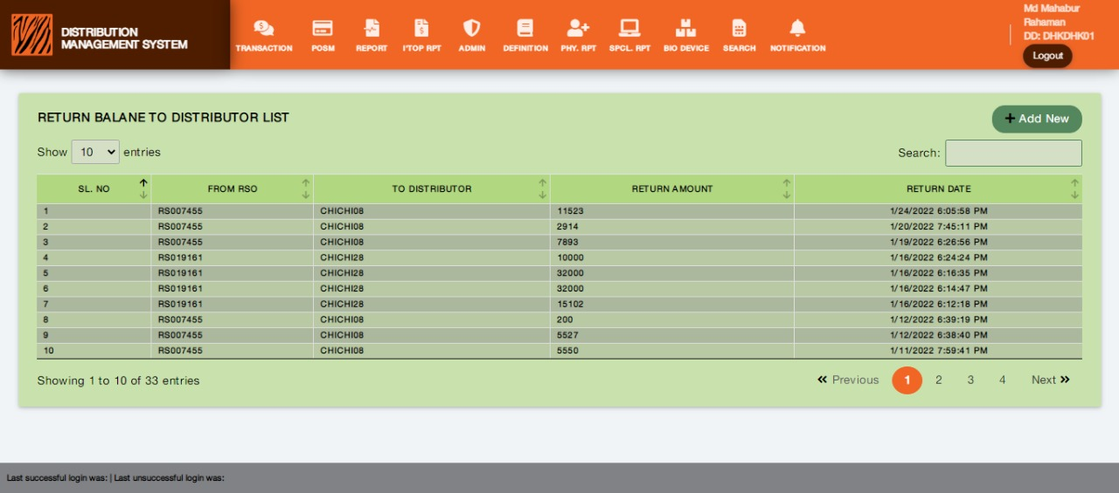**Figure: 23.2**

**Process:**

**Description: The Above process demonstrates how a user will**

**Figure: 23.2**

**Rules/Validation:**

# . FR 24- Distributor Stock Floor Report (SC).

**Reference:** FR 24 (DMS) (Business Recruitments Document).

**Functionalities:** Distributor Stock Floor Report (SC).

Report with details serial wise.

Details should not be from live data; they should be processed on previous days.

**Interfaces:**

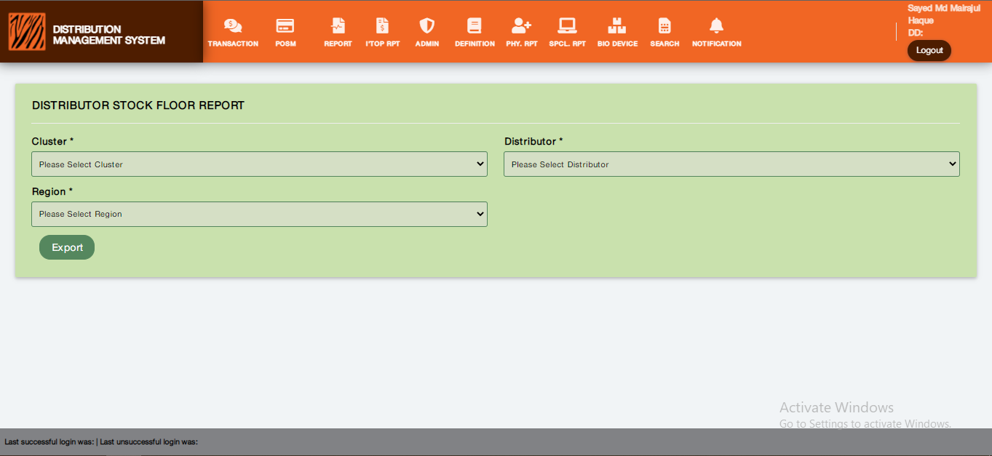**Figure: 24.1 Distributor Stock Floor Report**

**Process:**



**Description: The Above process demonstrates how a user will view Distributor Stock Floor Report.**

**Figure 24.1 Description:**

* **Cluster:** Cluster is an input field with a dropdown selection menu. It is a mandatory field.

**Rules/Validation:**

1. Any field or button must not overlap or break with each other.
2. Check the process works appropriately.
3. Check if the Excel Export download button works properly.